Highland Community College

2025 COMBINED ANNUAL SECURITY REPORT & FIRE SAFETY REPORT

Introduction
This report is provided in compliance with the Jeanne Clery Disclosure of Campus Security Policy and Crime Statistics Act, as amended. It provides students and employees of Highland Community College ("College") with information on: the College's security arrangements, policies and procedures; programs that provide education on such things as drug and alcohol abuse, awareness of various kinds of sex offenses, and the prevention of crime generally; and procedures the College will take to notify the campus community in the event of an emergency. Its purpose is to provide students and employees with information that will help them make informed decisions relating to their own safety and the safety of others.

Policy for Preparing the Annual Report
This report has been prepared by the Student Conduct and Compliance Officer in cooperation with local law enforcement authorities and includes information provided by them as well as by the College's campus security authorities and various other elements of the College. Each year an e-mail notification is made to all enrolled students and employees that provide the website link to access this report. Prospective students and employees are also notified of the report's availability. Hard copies of the report may also be obtained at no cost by contacting David Reist Administration Building, 602 W Main St., Highland, KS 66035. The College is committed to taking the actions necessary to provide a safe and secure working/learning environment for all students and staff. As a member of the campus community, you can feel safe and comfortable knowing that security procedures are in place that represent best practices in the field and are constantly tested and re-evaluated for their effectiveness.

General Safety and Security Policies

Campus Security Personnel & Relationship with Local Law Enforcement
The HCC Campus Security staff may be contacted by calling 785.741.2206.

Working With Law Enforcement

While HCC does not have any formal agreement with local law enforcement agencies, HCC does work with law enforcement agents as needed (or required by law), as determined by the appropriate HCC staff members, in consideration of the totality of facts for a given situation. HCC staff may elect to contact law enforcement agents for assistance in dealing with the conduct of students, faculty, staff, and/or other community members. Still, HCC does not do so with the express purpose of acting as agents of the police and/or not for the purpose of bringing criminal charges, though criminal charges may arise from HCC engaging law enforcement agents.

In some cases, HCC will cooperate with law enforcement agents, including cooperation with the investigation and/or prosecution of criminal activities; HCC, however, will cooperate only within the confines of legal and ethical boundaries respective to individual rights and protections under both the U.S. and Kansas State Constitutions. In all cases, HCC will maintain its autonomy, acting as its own agent in the interest of the institution’s mission/purpose and regarding the needs and rights of its students.

Campus Security Authorities
The College has designated certain officials to serve as campus security authorities. Reports of criminal activity can be made to these officials. They in turn will ensure that the crimes are reported for collection as part of the College's annual report on crime statistics. The campus security authorities, to whom the College would prefer that crimes be reported are listed below.

- Campus Security Officer at (785) 741-2206
- Resident Assistant On-Duty at (785) 850-1377
- Dean of Students/Title IX at (785) 442-6021
- Vice President of Academic Affairs at (785) 442-6050
- Vice President of Technical Education at (785) 442-6201
- Executive Vice President at (785) 442-6094
- Director of Human Resources/Title IX at (785) 442-6010
- Director of Technical Education at (785) 442-6180
- Director of Western Center at (785) 442-6240

Reporting a Crime or Emergency
The College encourages accurate and prompt reporting of all criminal actions, emergencies, or other incidents occurring on campus, on other property owned by the College, or on nearby public property to the appropriate administrator and appropriate police agencies. Such a report is encouraged when the victim of a crime elects to, or is unable to, make such a report.

The college encourages all crimes to be promptly reported to the HCC Security Department to ensure inclusion in the annual crime statistics. Security may be contacted by calling (785) 741-2206. All crimes should be reported to HCC Campus Security to aid in providing timely warnings to the college community when appropriate. The HCC Security office is located in the Laundry/Housing Building at 307 N. Elmira, Highland, KS. For immediate response to a crime, call 911. Crime reports may also be made to the HCC personnel (listed above) who are designated Campus Security Authorities (CSAs). For Clery Act reporting purposes, CSAs are HCC officials who have significant responsibility for student and campus activities, including, but not limited to student activities, student athletics, and student conduct personnel. Once reported the individual may also be encouraged to report the situation to the appropriate law enforcement agency. If requested, a College staff member will assist in making the report to police.

Anonymous reports may also be filed online, using the reporting form posted at www.highlandcc.edu.

Confidential Reporting

The College will protect the confidentiality of victims. Only those with a need to know the identity for purposes of investigating the crime, assisting the victim, or disciplining the perpetrator will know the victim's identity.

Highland Community College officials, depending on their roles at the College, have varying reporting responsibilities and abilities to maintain confidentiality. To make informed choices, one should be aware of confidentiality and mandatory reporting requirements when consulting campus resources. On campus, some resources may maintain confidentiality, offering options and advice without any obligation to inform an outside agency or individual unless you have requested information to be shared. Other resources exist for you to report crimes and policy violations, and these resources will act when you report victimization to them. Under Kansas Law, if either party is under 18 and has been reported to be physically, mentally, or sexually abused, college authorities are mandated to report the alleged abuse to law enforcement. For people 18 and older, there are options for the report to be confidential, private, or formal.

If a reporting party would like the details of an incident to be kept confidential, the reporting party may speak with a local off-campus rape crisis counselors, domestic violence resources, local or state assistance agencies, local (off-campus) members of the clergy/chaplains who will maintain confidentiality except in extreme cases of immediacy of threat or danger or abuse of a minor.

Private (Voluntary) Reporting
Those seeking to report misconduct may seek advice from certain resources who are not required to initially tell anyone else your private, personally identifiable information unless there is a pattern of abuse, cause for fear for your safety or the safety of others, or either party is under 18 years of age. These resources include employees without supervisory responsibility or remedial authority to address discrimination, harassment, retaliation, and/or sexual misconduct, such as admissions officers, Student Support Services staff (transfer, retention), full-time front desk personnel in all regional centers and the Wellness Center on the Highland campus. If a reporting party is unsure of someone’s duties and ability to maintain privacy, ask them before talking to them. They will be able to explain and help a reporting party to make decisions about who is in the best position to help.

HCC Employees are instructed to share incident reports with their supervisors, but they do not share any personally identifiable information about the report unless the reporting party gives permission or they are under 18, except in the rare event that the incident reveals a need to protect the reporting party and/or other members of the community. If personally identifiable information is shared, it will be shared with as few people as possible, and all efforts will be made to protect privacy to the greatest possible extent.

Formal Reporting Options
A party bringing a grievance is encouraged to speak to College officials, such as the appropriate Title IX Coordinator, EGP (Equity Grievance Panel) members, Director of Campus Engagement, Student Conduct and Compliance Officer, Campus Safety & Security Coordinator, to make formal reports of incidents of sexual misconduct. A party bringing a grievance has the right, and can expect, to have grievances taken seriously by the College when formally reported, and to have those incidents investigated and properly resolved through these procedures. Formal reporting still affords privacy for the reporter, and only a small group of officials who need to know will be told. Information will be shared as necessary with investigators, witnesses, and the responding

party. The circle of people with this knowledge will be kept as tight as possible to preserve a party bringing a grievance’s rights and privacy.

The College encourages its professional counselors, if and when they deem it appropriate, to inform the person they are counseling to report crimes on a voluntary, confidential basis for inclusion in the annual report on crime statistics. The College does not have any pastoral counselors.

Security of and Access to Campus Facilities
Regular operating hours of HCC offices are 8:00 a.m. to 5:00 p.m. Some buildings will be open evenings or weekends for classes or special events. Only employees who have been issued keys to the areas being entered are allowed access to those areas. Residence facilities on campus are also only accessed by residents who have been issued keys for their specific residence. In the event, an individual is found with HCC keys, without proper authorization, and that individual will be asked to relinquish the keys. If they choose not to abide by the request, local law enforcement will be notified immediately.

Highland Campus security officers are on duty in the evening hours, seven days per week, and regularly patrol campus parking lots, housing areas, academic building areas, cafeteria, library, and main campus grounds during that time. Daytime security issues are handled by the HCC Safety Management Team. Regional centers (Atchison Tech. Center, Wamego Center, and Western Center in Baileyville) may be patrolled by local law enforcement in that jurisdiction. Any person at the Highland, Kansas location wanting to request a campus escort should contact HCC Security at (785) 741-2206.

Students and employees are asked to be alert and not to circumvent practices and procedures that are meant to preserve their safety and that of others:
- Do not prop doors open or allow strangers into campus buildings that have been secured
- Do not lend keys or access cards to non-students and do not leave them unattended
- Do not give access codes to anyone who does not belong to the campus community

Security Considerations in the Maintenance of Facilities
The Campus Security Department works with the Facilities Department to identify maintenance issues on campus that may be safety hazards. Property maintenance of the main campus facility is monitored by HCC’s Maintenance Department. Safety checks are completed to identify street or safety lights that are not functioning properly, or to determine if shrubs or other landscaping might need trimming. Maintenance personnel regularly check to ensure there is adequate lighting on pathways and that egress lighting is working in hallways and stairwells.

Educational Programs Related to Security Awareness and Prevention of Criminal Activity
The College seeks to enhance the security of its campus and the members of the campus community by periodically presenting educational programs to inform students and employees about campus security procedures and practices, to encourage students and employees to be responsible for their own security and the security of others and to inform them about the prevention of crimes. These programs are discussed below.

- (Mandatory, Student) Housing Meeting - First Week (after Move-In), each Semester: Review of campus (Housing) policies and procedures
- (Mandatory, Student) New Student Orientation - Prior to the Start of Each Semester: Review of campus policies, procedures, prevention, and services
- (Mandatory, Student) College Success - Offered Fall and Spring, only: This course is an introduction to the world of college. The course will include preparation of an academic plan to obtain an associate degree in a selected major. The course will also cover curriculum structure, college success skills, transferring to a four-year institution, decision-making, and career planning. Also, Review of campus policies, procedures, and services.
- (Employee, As Applicable) Campus Security Authority (CSA) Training - Yearly: Requirements on employee obligations for reporting (Clery) crimes.
- (Employee, As Applicable) In-Service Training - Yearly: Each area provides staff with yearly opportunities for professional development, including components addressing safety, security, reporting, and personal responsibility.

Monitoring Off Campus Locations of Recognized Student Organizations
The College does not have any officially recognized student organizations with off campus locations and therefore does not monitor or record criminal conduct occurring at such locations.

Disclosure of the Outcome of a Crime of Violence or Non-Forcible Sex Offense
Upon written request, the College will disclose to the alleged victim of a crime of violence (as that term is defined in section 16 of title 18, United States Code), or a non-forcible sex offense, the report on the results of any disciplinary proceeding conducted by the College against a student who is the alleged perpetrator of such crime or offense. If the alleged victim is deceased as a result of such crime or offense, the next of kin of such victim shall be treated as the alleged victim for purposes of the paragraph.

The previous paragraph does not apply to victims of dating violence, domestic violence, sexual assault, or stalking because under the Violence Against Women Act both the accused and accuser in these cases are given the results without the need to make a written request.

Drug and Alcohol Policy

The possession, sale, furnishing, or use of alcohol or drugs at HCC is governed by federal law, Kansas law, and college policies. All the following policies may be found in the student handbook at http://highlandcc.edu/pages/handbook.

- Student Code of Conduct
- Drug-Free Schools and Communities Act and Drug-Free Workplace Act statement

Students, employees, or visitors that violate federal or state laws concerning the possession, use, or sale of drugs or alcohol are subject to criminal prosecution, as HCC actively enforces these laws. In addition, for students and employees, the college considers a violation of its drug and alcohol policies to be a major offense that can result in mandated participation in a drug or alcohol rehabilitation program, referral for a criminal prosecution, and/or immediate disciplinary action, up to and including termination from employment (for employees) and either suspension or expulsion from the college (for students).

HCC's Drug Policy: See Statement Above

Federal Drug Laws (updated 08.05.2024)

Denial of Federal Benefits (21 U.S.C. § 862) A federal drug conviction may result in the loss of federal benefits, including loans, grants, scholarships, contracts, and licenses, although the Department of Education has said it will no longer disqualify students from Title IV aid for a federal or state conviction for possession or sale of a controlled substance.

Forfeiture of Personal Property and Real Estate (21 U.S.C. § 853) Any person convicted of a federal drug offense punishable by more than one year in prison shall forfeit to the United States any personal or real property related to the violation. A warrant of seizure may be issued and property seized at the time an individual is arrested on charges that may result in forfeiture.

Federal Drug Trafficking Penalties (21 U.S.C. § 841) Penalties for federal drug trafficking convictions vary according to the type and quantity of the controlled substance involved in the transaction. Penalties for subsequent convictions are more severe. Federally defined schedules of controlled substances are published at 21 U.S.C. 812.

In the case of a controlled substance in schedule I or schedule II, GHB (or, “liquid ecstasy”), or flunitrazepam (or, “Rohypnol”), a person shall be sentenced to a term of imprisonment of not more than 20 years. If death or serious bodily injury results from the use of a controlled substance which has been illegally distributed, the person convicted on federal charges of distributing the substance faces the possibility of a life sentence and fines ranging up to $10 million.

In the case of a controlled substance in schedule III, a person shall be sentenced to a term of imprisonment of not more than 10 years, and if death or serious bodily injury results, shall be sentenced to a term of imprisonment of not more than 15 years or a fine not to exceed
$500,000, or both, for a first offense.

For less than 50 kilograms of marijuana, the term of imprisonment shall not be more than five years, and the fine shall not be more than $250,000, or both, for a first offense.

In the case of a schedule IV substance, the term of imprisonment shall not be more than five years, and the fine shall not be more than $250,000, or both, for a first offense.

Persons convicted on federal charges of drug trafficking within 1,000 feet of an elementary school, secondary school, college, or university (21 U.S.C. § 860) face penalties of prison terms and fines which are twice as high as the regular penalties for the offense, with a mandatory prison sentence of at least one year, unless the offense involves five grams or less of marijuana.

Federal Drug Possession Penalties (21 U.S.C. § 844) Persons convicted on federal charges of possessing any controlled substance face penalties of up to one year in prison, a mandatory fine of no less than $1,000, or both. Second convictions are punishable by not less than 15 days but not more than two years in prison and a minimum fine of $2,500. Subsequent convictions are punishable by not less than 90 days but not more than three years in prison and a minimum fine of $5,000.

For the most recent and complete Federal Trafficking Penalties information, visit the website of the U.S. Drug Enforcement Administration at www.campusdrugprevention.gov/sites/default/files/2022- 07/Federal_Trafficking_Penalties_Chart_6-23-22.pdf.
Drug and Alcohol State Laws

Category | Summary (Kansas Statutes)
Possession of Marijuana | Possession of marijuana is a Class B nonperson misdemeanor in Kansas with the possibility of up to six months incarceration and a fine of up to $1,000. Kan. Stat. Ann. §§ 21-5706(c)(3)(A), 21-6602, 21-6611. Penalties increase with additional convictions. §§ 21-5706(c)(3)(B)–(C), 21-6602, 21.6611. Distribution or possession with intent to distribute marijuana is a drug severity level 4 felony for quantities of less than 25 grams. § 21- 5705. A Level 4 felony can result in up to 51 months imprisonment. § 21-6805. Kansas does not allow the medical use of marijuana.
Controlled Substances | It is illegal in Kansas to be in possession of a controlled substance. § 21- 5706(a)–(b). Penalties vary widely based on the offense and the defendant’s criminal history. §§ 21-5705 – 21-5710.  Possession of opiates, opium, or certain stimulants (including ethamphetamine) is a Level 5 felony for which a defendant faces up to 3.5 years in prison and $100,000 in fines. §§ 21-5706(c)(1), 21-6611(a)(3). For certain other drugs, the first offense is a Class A nonperson misdemeanor, with up to a year in prison and up to $2,500 in fines. Prior offenses result in a Level 5 felony. § 21-5706(c)(2)(B). Possession of drug paraphernalia is a Class B nonperson misdemeanor or a Level 5 felony, depending on how the paraphernalia is used. § 21-5709.  Distribution of controlled substances is also illegal, with punishments dependent on the substance and the amount. § 21-5705. Possession of larger quantities of controlled substances results in an inference of an intent to distribute. § 21-5705(e).
Alcohol and Minors | No person under the age of 21 shall possess, consume, obtain, purchase, or attempt to obtain or purchase alcoholic beverages. § 41-727. A violation, for a person aged 18 to 20, constitutes a Class C misdemeanor with a fine of $200 to $500 and imprisonment for up to one month. Id. It may also result in 40 hours of community service and/or completion of an educational training program regarding the results of alcohol and other chemical substances. Id. Second convictions result in a 90-day loss of driving privileges. Id. Third convictions result in a one-year loss of driving privileges. Id.  Furnishing alcoholic liquor or cereal malt beverage to a minor is a Class B person misdemeanor, punishable by a fine of $200 to $1000 and imprisonment for up to 6 months. § 21-5607(c)(1). It is also illegal for any person under the age of 21 to display or have in possession any fictitious or fraudulently altered identification card for use in the purchase of any alcoholic liquor or cereal malt beverage. § 8-1327(c)(4). A first violation constitutes a Class B nonperson misdemeanor with a sentence of not less than 100 hours of public service, up to 6 months imprisonment, and a fine of not less than $200 nor more than $500. § 8-1327(d)(1).

Category | Summary (Kansas Statutes)
Driving Under the Influence (DUI) | It is illegal to operate or attempt to operate a car with a blood alcohol content of 0.08 percent or greater or while under the influence of alcohol or any drug to a degree that renders a person incapable of safely driving a vehicle. § 8-1567(a). A first offense is a Class B nonperson misdemeanor with a minimum imprisonment of 48 consecutive hours up to six months (or 100 hours of public service in the court’s discretion) and a fine of $750–$1,000. § 8-1567(b)(1)(A).  For a second offense, the penalties increase to a Class A nonperson misdemeanor with a term of imprisonment of 90 days to one year and a fine of not less than $1,250 nor more than $1,750. § 8-1567(b)(1)(B). It is also unlawful for any person less than 21 years of age to operate or attempt to operate a vehicle with a breath or blood alcohol content of .02 or greater. § 8-1567a(a). For a first offense, the person’s driving privileges will be suspended for 30 days and then restricted for an additional 180 days. § 8-1567a(f). It is generally illegal to operate a motor vehicle with an opened alcoholic beverage in your possession. § 8-1599. A violation is a misdemeanor punishable by a fine of not more than $200 or by imprisonment for not more than six months, or both. Id.

Drug and Alcohol Abuse Prevention Program
In compliance with the Drug Free Schools and Communities Act (DFSCA), the College has a drug and alcohol abuse and prevention program, which includes an annual notification to students and employees regarding certain drug/alcohol-related information (such as legal sanctions for violations of applicable laws, health risks, etc.) and a biennial review of this program to evaluate its effectiveness and assess whether sanctions are being consistently enforced. For more information, see below.

- HCC's Drug and Alcohol Prevention Program Policy (Updated January 2022)
- Annual notification: please contact the Dean of Students, Lexy Clark (lclark@highlandcc.edu)
- Biennial review report: please contact the Dean of Students, Lexy Clark (lclark@highlandcc.edu)

Policies, Procedures, and Programs Related to Dating Violence, Domestic Violence, Sexual Assault, and Stalking

Consistent with applicable laws, the College prohibits dating violence, domestic violence, sexual assault, and stalking. The College's policy used to address complaints of this nature, as well as the procedures for filing, investigating, and resolving complaints, may be found at:

- Equity Grievance Policy (EGP): Link Here

The following sections of this report discuss the College's educational programs to promote the awareness of dating violence, domestic violence, sexual assault and stalking; provides information concerning procedures students and employees should follow and the services available in the event they do become a victim of one of these offenses, and advises students and employees of the disciplinary procedures that will be followed after an allegation that one of these offenses has occurred.

Primary Prevention and Awareness Program:
The College conducts a Primary Prevention and Awareness Program (PPAP) for all incoming students and new employees. The PPAP advises campus community members that the College prohibits the offenses of dating violence, domestic violence, sexual assault, and stalking. They are also informed of the topics discussed below, including relevant definitions, risk reduction, and bystander intervention.

Crime Definitions

Crime Type (Kansas Statutes Annotated) | Definitions
Dating Violence | The institution has determined, based on good-faith research, that Kansas  law does not define the term dating violence.
Domestic Violence | - Domestic Violence (Kan. Stat. Ann. § 21-5111): “Domestic violence” means an act or threatened act of violence against a  person with whom the offender is involved or has been involved in a dating relationship, or an act or threatened act of violence against a family or household member by a family or household member. “Domestic violence” also includes any other crime committed against a person or against property, or any municipal ordinance violation against a person or against property, when directed against a person with whom the offender is involved or has been involved in a dating relationship or when directed against a family or household member by a family or household member.  - Domestic Battery (Kan. Stat. Ann. § 21-5414(a)): Domestic battery is (1) Knowingly or recklessly causing bodily harm to a person with whom the offender is involved or has been involved in a dating relationship or a family or household member; or (2) knowingly causing physical contact with a person with whom the offender is involved or has been involved in a dating relationship or a family or household member, when done in a rude, insulting or angry manner.  - Aggravated Domestic Battery (Kan. Stat. Ann. § 21-5414(b)): Aggravated domestic battery is: (1) Knowingly impeding the normal breathing or circulation of the blood by applying pressure on the throat, neck or chest of a person with whom the offender is involved or has been involved in a dating relationship or a family or household member, when done in a rude, insulting or angry manner; or (2) knowingly impeding the normal breathing or circulation of the blood by blocking the nose or mouth of a person with whom the offender is involved or has been involved in a dating relationship or a family or household member, when done in a rude, insulting or angry manner.

Crime Type (Kansas Statutes Annotated) | Definitions
For the purpose of the above definitions:

- “Dating relationship” means a social relationship of a romantic nature. In addition to any other factors the court deems relevant, the trier of fact may consider the following when making a determination of whether a relationship exists or existed: Nature of the relationship, length of time the relationship existed, frequency of interaction between the parties and time since termination of the relationship, if applicable.
- “Family or household member” means persons 18 years of age or older who are spouses, former spouses, parents or stepparents and children or stepchildren, and person who are presently residing together or have resided together in the past, and persons who have a child in common regardless of whether they have been married or have lived together at any time. “Family and household member” also includes a man and woman if the woman is pregnant and the man is the alleged father, regardless of whether they have been married or have lived together at any time.
Stalking (Kan. Stat. Ann. § 21- 5427) | - Stalking is: (1) Recklessly engaging in a course of conduct targeted at a specific person which would cause a reasonable person in the circumstances of the targeted person to fear for such person's safety, or the safety of a member of such person's immediate family and the targeted person is actually placed in such fear; (2) Engaging in a course of conduct targeted at a specific person with knowledge that the course of conduct will place the targeted person in fear for such person's safety or the safety of a member of such person's immediate family; or (3) After being served with, or otherwise provided notice of any protective order…that prohibits contact with a targeted person, recklessly engaging in at least one act listed [below] that violates the provisions of the order and would cause a reasonable person to fear for such person's safety, or the safety of a member of such person's immediate family and the targeted person is actually placed in such fear; or intentionally engaging in a course of conduct targeted at a specific child under the age of 14 that would cause a reasonable person in the  circumstances of the targeted child, or a reasonable person in the circumstances of an immediate family member of such child, to fear for such child’s safety.  - “Course of conduct” means two or more acts over a period of time, however short, which evidence a continuity of purpose. A course of conduct shall not include constitutionally protected activity nor conduct that was necessary to accomplish a legitimate purpose independent of making contact with the targeted person. A course of conduct shall include, but not be limited to, any of the following acts or a combination thereof: (A) Threatening the safety of the targeted person or a member of such person's immediate family;

Crime Type (Kansas Statutes Annotated) | Definitions
(B) Following, approaching or confronting the targeted person or a member of such person's immediate family; (C) Appearing in close proximity to, or entering the targeted person's residence, place of employment, school or other place where such person can be found, or the residence, place of employment or school of a member of such person's immediate family; (D) Causing damage to the targeted person's residence or property or that of a member of such person's immediate family; (E) Placing an object on the targeted person's property or the property of a member of such person's immediate family, either directly or through a third person; (F) Causing injury to the targeted person's pet or a pet belonging to a member of such person's immediate family; (G) Utilizing any electronic tracking system or acquiring tracking information to determine the targeted person’s location, movement or travel patterns; and (H) Any act of communication.
- “Immediate Family” means: (A) father, mother, stepparent, child, stepchild, sibling, spouse or grandparent of the targeted person; (B) any person residing in the household of the targeted person; or (C) any person involved in an intimate relationship with the targeted person.
Sexual Assault | The institution has determined, based on good-faith research, that Kansas law does not define the term sexual assault.
Rape, Fondling, Incest, Statutory Rape | For purposes of the Clery Act, the term “sexual assault” includes the offenses of rape, fondling, incest, and statutory rape. These definitions under Kansas law are as follows:  - Rape (Kan. Stat. Ann. § 21-5503): (1) Knowingly engaging in sexual intercourse with a victim who does not consent to the sexual intercourse under any of the following circumstances: (A) When the victim is overcome by force or fear; or (B) when the victim is unconscious or physically powerless; (2) Knowingly engaging in sexual intercourse with a victim when the victim is incapable of giving consent because of mental deficiency or disease, or when the victim is incapable of giving consent because of the effect of any alcoholic liquor, narcotic, drug or other substance, which  condition was known by the offender or was reasonably apparent  to the offender; (3) sexual intercourse with a child who is under 14 years of age; (4) sexual intercourse with a victim when the victim's consent was obtained through a knowing misrepresentation made by the offender that the sexual intercourse was a medically or therapeutically necessary procedure; or (5) sexual intercourse with a victim when the victim's consent was obtained through a knowing misrepresentation made by the offender that the sexual intercourse was a legally required procedure within the scope of the offender's authority.  - Fondling: The institution has determined, based on good-faith research, that Kansas law does not define the term fondling.  - Incest (Kan. Stat. Ann. § 21-5604(a)): Incest is marriage to or engaging in otherwise lawful sexual intercourse or sodomy, as defined in K.S.A. 21-5501, and amendments thereto, with a person who is 18 or more years of age and who is known to the offender to be related to the offender as any of the following biological relatives: Parent, child, grandparent of any degree, grandchild of any degree, brother, sister, half-brother, half-sister, uncle, aunt, nephew or niece.  - Aggravated Incest (Kan. Stat. Ann. § 21-5604(b)): Aggravated incest is (1) Marriage to a person who is under 18 years of age and who is known to the offender to be related to the offender as any of the following biological, step or adoptive relatives: Child, grandchild of any degree, brother, sister, half-brother, half-sister, uncle, aunt, nephew or niece; or (2) engaging in the following acts with a person who is 16 or more years of age but under 18 years of age and who is known to the offender to be related to the offender as any of the following biological, step or adoptive relatives: Child, grandchild of any degree, brother, sister, half-brother, half-sister, uncle, aunt, nephew or niece: (A) Otherwise lawful sexual intercourse or sodomy as defined by K.S.A. 21-5501, and amendments thereto; or (B) any lewd fondling, as described in subsection (a)(1) of K.S.A. 21-5506, and amendments thereto.  Statutory Rape: The institution has determined, based on good- faith research, that Kansas law does not define the term statutory rape.

Other "sexual assault" crimes | Other crimes under Kansas law that may be classified as a “sexual assault” include the following:  - Criminal Sodomy (Kan. Stat. Ann. § 21-5504(a)): Criminal sodomy is: (1) Sodomy between persons who are 16 or more years of age and members of the same sex* [this provision was found unconstitutional as applied by State v. Franco, 319 P.3d 551 (2014) and thus unenforceable with regard to any intercourse between consenting adults of the same sex conducted in private;  (2) sodomy between a person and an animal; (3) sodomy with a child who is 14 or more years of age but less than 16 years of age; or (4) causing a child 14 or more years of age but less than 16 years of age to engage in sodomy with any person or animal.  - Aggravated Criminal Sodomy (Kan. Stat. Ann. § 21-5504(b)): Aggravated criminal sodomy is: (1) Sodomy with a child who is under 14 years of age; (2) causing a child under 14 years of age to engage in sodomy with any person or an animal; or (3) sodomy with a victim who does not consent to the sodomy or causing a victim, without the victim's consent, to engage in sodomy with any person or an animal under any of the following circumstances: (A) When the victim is overcome by force or fear; (B) when the victim is unconscious or physically powerless; or (C) when the victim is incapable of giving consent because of mental deficiency or disease, or when the victim is incapable of giving consent because of the effect of any alcoholic liquor, narcotic, drug or other substance, which condition was known by, or was reasonably apparent to, the offender.

- Sexual Battery (Kan. Stat. Ann. § 21-5505(a)): Sexual battery is the touching of a victim who is 16 or more years of age and who does not consent thereto, with the intent to arouse or satisfy the sexual desires of the offender or another.
- Aggravated Sexual Battery (Kan. Stat. Ann. § 21-5505(b)): Aggravated sexual battery is sexual battery, as defined in subsection (a), under any of the following circumstances: (1) When the victim is overcome by force or fear; (2) when the victim is unconscious or physically powerless; or (3) when the victim is incapable of giving consent because of mental deficiency or disease, or when the victim is incapable of giving consent because of the effect of any alcoholic liquor, narcotic, drug or other substance, which condition was known by, or was reasonably apparent to, the offender.
- Indecent Liberties with a Child (Kan. Stat. Ann. § 21-5506(a)): Indecent liberties with a child is engaging in any of the following acts with a child who is 14 or more years of age but less than 16 years of age: (1) Any lewd fondling or touching of the person of either the child or the offender, done or submitted to with the intent to arouse or to satisfy the sexual desires of either the child or the offender, or both; or (2) soliciting the child to engage in any lewd fondling or touching of the person of another with the intent to arouse or satisfy the sexual desires of the child, the offender or another.
- Aggravated Indecent Liberties with a Child (Kan. Stat. Ann. § 21- 5506(b)): Aggravated indecent liberties with a child is: (1) Sexual intercourse with a child who is 14 or more years of age but less than 16 years of age; (2) engaging in any of the following acts with
a child who is 14 or more years of age but less than 16 years of age and who does not consent thereto: (A) Any lewd fondling or touching of the person of either the child or the offender, done or submitted to with the intent to arouse or to satisfy the sexual desires of either the child or the offender, or both; or (B) causing the child to engage in any lewd fondling or touching of the person of another with the intent to arouse or satisfy the sexual desires of the child, the offender or another; or (3) engaging in any of the following acts with a child who is under 14 years of age: (A) Any lewd fondling or touching of the person of either the child or the offender, done or submitted to with the intent to arouse or to satisfy the sexual desires of either the child or the offender, or both; or (B) soliciting the child to engage in any lewd fondling or touching of the person of another with the intent to arouse or satisfy the sexual desires of the child, the offender or another.
- Unlawful voluntary sexual relations (Kan. Stat. Ann. § 21-5507): Unlawful voluntary sexual relations is:
  - (1) Engaging in any of the following acts with a child who is 14 or more years of age but less than 16 years of age:
    - (A) Voluntary sexual intercourse;
    - (B) voluntary sodomy; or
    - (C) voluntary lewd fondling or touching;
  - (2) when the offender is less than 19 years of age;
  - (3) when the offender is less than four years of age older than the child;
  - (4) when the child and the offender are the only parties involved; and
(5) when the child and the offender are members of the opposite sex.
Consent (as it relates to sexual activity) | The institution has determined, based on good-faith research, that Kansas law does not define the term consent (as it relates to sexual activity).

College Definition of Consent

The College uses the following definition of consent in its Policy and Procedure for Civil Rights Equity Grievance Resolution for All Faculty, Students and Employees:

Consent is knowing, voluntary and clear permission by word or action, to engage in mutually agreed upon sexual activity. Since individuals may experience the same interaction in different ways, it is the responsibility of each party to make certain that the other has consented before engaging in the activity. For consent to be valid, there must be a clear expression in words or actions that the other individual consented to that specific sexual conduct.

A person cannot consent if he or she is unable to understand what is happening or is disoriented, helpless, asleep, or unconscious for any reason, including due to alcohol or other drugs. An individual who engages in sexual activity when the individual knows, or should know, that the other person is physically or mentally incapacitated has violated this policy.

It is not an excuse that the individual responding party of sexual misconduct was intoxicated and, therefore, did not realize the incapacity of the other. Incapacitation is defined as a state where someone cannot make rational, reasonable decisions because they lack the capacity to give knowing consent (e.g., to understand the “who, what, when, where, why or how” of their sexual interaction). This policy also covers a person whose incapacity results from mental disability, involuntary physical restraint and/or from the taking of incapacitating drugs.

Consent to some sexual contact (such as kissing or fondling) cannot be presumed to be consent for other sexual activity (such as intercourse). A current or previous dating relationship is not sufficient to constitute consent. The existence of consent is based on the totality of the circumstances, including the context in which the alleged incident occurred and any similar previous patterns that may be evidenced. Silence or the absence of resistance alone is not consent. A person can withdraw consent at any time during sexual activity by expressing in words or actions that he or she no longer wants the act to continue, and, if that happens, the other person must stop immediately.

In Kansas, a minor (meaning a person under the age of 16 years) cannot consent to sexual activity. This means that sexual contact by an adult with a person younger than 16 years old, consenting and unconsenting, is a crime.

Risk Reduction

SAFETY AND SECURITY TIPS FOR PREVENTING SEXUAL ASSAULT
If you find yourself in an uncomfortable sexual situation, these situations may help reduce your risk:

On-Campus

- Never walk alone at night. Call a friend or (785) 741-2206 (Campus Security) for an escort.
- Always be aware of your surroundings. Walk purposefully and make eye contact with strangers.
- In parking lots, have keys ready when you approach your car to make your entry easier.
- After dark, try to park in a well-lit area close to your destination.
- Always lock car doors and roll-up windows. Keep valuables out of sight or in the trunk.
- If you feel threatened, immediately go to an open building where there are other people
- Never leave personal items unattended or unlocked.
- Emergency 911 telephone calls on cellular telephones will not be answered by HCC Security but will be directed to a 911 Call Center. For faster assistance, please advise the officer who answers the telephone that your emergency is occurring on the HCC campus.

At Home

- Always lock all doors, even when you are there. Take keys with you, even when stepping out for “just a second.”
- Keep windows locked.
- Don’t loan out your keys or leave them lying around. Detach your house keys from the main ring when having vehicles serviced.
- Utilize peepholes or safety chains. Don’t open doors without verifying the identity of the person on the other side.
- Don’t keep expensive jewelry, collectibles, or large amounts of cash at home.
- Don’t advertise your absence, especially on your answering machine or a social media site.

In Social Situations

- When dating someone you don’t know well, ask people you trust about your date.
- Socialize in groups so that you’re not alone with just one person. There really is safety in
numbers.
- Drive yourself and carry extra money in case you need to get home alone.
- If you feel uncomfortable, there’s probably a reason. It’s better to do something you may
consider rude than to remain in a dangerous situation.
- Remember that alcohol impairs both your decision-making processes and the ability to communicate.
- Keep all drinking glasses, bottles, or other open containers in sight at all times. When accepting a drink of some kind, make sure that you open the container yourself and be aware that ice cubes could contain harmful substances as well.

On Social Media Sites

- Don’t give out information simply because it is requested.
- Giving out birthdates, full names, addresses, phone numbers, Social Security numbers, bank or credit card accounts and other personally identifiable information can lead to identify theft and cyber stalking.
- Select gender-neutral usernames.
- Protect your passwords.
- Be cautious about posting pictures of yourself, as stalkers sometimes can become obsessed by photos or images.
- Versions of online information can be archived, so once you post information, deleting it does not ensure that it is no longer available online.
- Be cautious about arranging personal meetings with new online acquaintances.
- Only post information that you are comfortable having others see, including parents, potential employers, instructors, etc.
- Trust your instincts.

Protect/Watch Your Drinks

- Never leave your drink unattended. Because they are colorless and odorless, drugs used in drug-facilitated sexual assault can be slipped into any type of beverage.
- Do not accept drinks from anyone but a bartender or server. Try to attend bars or parties with a group of friends, arranging beforehand to watch each other’s drinks.
- If you think your drink has been tampered with, seek medical attention immediately and request the hospital conduct toxicology testing.

Bystander Intervention

WHAT CAN YOU DO TO HELP PREVENT SEXUAL ASSAULT AND MISCONDUCT?
A large part of preventing Sexual Assault involves recognition of warning signs and early intervention efforts.

What Does It Mean to Be an Active Bystander?

Through a variety of training and educational opportunities, HCC encourages students and employees to be active bystanders. This means that as an active BYSTANDER, you care about the HCC community, as well as the surrounding community you live in. Rather than being passive, Active BYSTANDERS when they witness troubling behavior, act to make sure that HCC is a safe, accepting, and fun place to go to school and work.

Being an Active BYSTANDER means being aware, deciding to act, and when you “see something, you say something.”

Many situations would call for an Active BYSTANDER to intervene, including disrespectful or abusive behavior, homophobic, racist, or sexist jokes, discrimination, risky behavior resulting from substance use, hate behavior or comments, or taking advantage of power imbalances (like status, size, or level of inebriation).

Being an active bystander doesn’t have to be dramatic. It can be as simples as saying something like, “Are you okay?” or “Can I talk to you for a sec?” or “That’s really not cool,” or “Are you kidding me, really?”

Some keys to safe BYSTANDER actions are:

Get Some Backup:
- Get your friends together-it’s time to leave.
- Get your friends for backup. Sometimes having your friends to back you up makes it easier to intervene.
- If intervening in the situation would be dangerous for you to do, call HCC Security at 785.741.2206 or 911-it’s always an option for intervention.

Distraction:
- Invite yourself to tag along.
- Hey, this party is lame, let’s go somewhere else.

Silent Stare:
- Sometimes a disapproving look can be far more powerful than words.

Humor:
- Reduces the tension of intervention and makes it easier for the person to hear you
- Do not undermine what you say with too much humor.
- Funny doesn’t mean unimportant.

Bring It Home:
- Say something, “I hope no one ever talks to you like that.”
- Challenge a sexist/rape joke, “I don’t get it, can you explain why that joke is funny?”

Be a Friend:
- “I gotta tell you that the way you acted makes you look like a jerk.”
- “As your friend, I thought you were better than this.”

Other Information Covered by the PPAP

The PPAP also provides information on possible sanctions and protective measures that may be imposed following a determination that an offense of dating violence, domestic violence, sexual assault, or stalking has occurred, an explanation of the disciplinary procedures that will be followed when one of these offenses is alleged, the rights of the parties in such a proceeding, available resources, and other pertinent information. Much of this information is set forth in the upcoming sections of this security report.

Ongoing Prevention and Awareness Campaign:
The College also conducts an Ongoing Prevention and Awareness Campaign (OPAC) aimed at all students and employees. This campaign covers the same material as provided in the PPAP but is intended to increase the understanding of students and employees on these topics and to improve their skills for addressing the offenses of dating violence, domestic violence, sexual assault, and stalking.

PPAP and OPAC Programming Methods:
The PPAP and OPAC are carried out in a variety of ways, using a range of strategies, and, as appropriate, targeting specific audiences throughout the College. The college has programs in place designed to provide education regarding safety and security, including the prevention of sexual assault. These programs are sponsored through Student Life, the Safety Management Team, and the Care and Threat Assessment Team and include the following:
- All students are required to attend orientation seminars to inform them of appropriate safety and security measures that the College offers. A required housing orientation for all students living in campus housing is also conducted. Both activities inform students of what to do in case of an emergency.
- A mandatory training video on Preventing Sexual Misconduct; for identified high-risk groups.
- Opportunities to attend ongoing programming sessions related to Personal Safety issues such as Sexual Assault, Domestic and Dating Violence, Hate Crimes, Stalking, Active Bystander, and Drug & Alcohol issues.
- Faculty and Staff are provided with information and guidance on helping students in a crisis.
- All new employees are required to complete the Vector Solutions Training modules provided through the Human Resources Office. These training programs and additional information located on the intranet inform employees of what to do in case of an emergency and provide them with a copy of the crisis plan.
- The HCC Safety Management Team and Care and Behavior Intervention teams offer educational programs, presentations, and literature promoting responsible decision-making and providing education on the legal consequences of alcohol and drug use. The department has an excellent supply of brochures, posters, and other printed materials about this subject, which are available to the college community and the public free of charge. Special emphasis is placed on personal safety and every student, staff member, faculty member, or visitor is encouraged to take a responsible and proactive approach to their safety and security. The goal of these programs is to make the campus environment as safe and crime-free as possible by raising the level of awareness of individuals and promoting a willingness to assume individual responsibility in reducing opportunities for crime to occur.

Procedures to Follow if You are a Victim of Dating Violence, Domestic Violence, Sexual Assault, or Stalking:
Students or Employees who wish to report instances of dating violence, domestic violence, sexual assault, or stalking may call 911 and may also call:

(Student Title IX Coordinator) Dean of Students - (785) 442-6021
(Employee Title IX Coordinator) Director of Human Resources - (785) 442-6010
Campus Safety & Security Coordinator - (785) 741-2206

Or Online Reports:
Discrimination, Harassment, Gender-Based Misconduct Reporting Form

Victims will be notified in writing of the procedures to follow, including:
- To whom and how the alleged offense should be reported (contact the Title IX Coordinator or refer to the other resources listed in this report).
- The importance of preserving evidence that may be necessary to prove the offense in a criminal proceeding or disciplinary action or to obtain a protective order.
- The victim’s options regarding notification to law enforcement, which are: (a) the option to notify either on-campus or local police; (b) the option to be assisted by campus security authorities in notifying law enforcement if the victim so chooses (the institution is obligated to comply with such a request if it is made); and (c) the option to decline to notify such authorities.
- Where applicable, the rights of victims and the institution’s responsibilities regarding orders of protection, no-contact orders, restraining orders, or similar lawful orders issued by a criminal, civil, or tribal court.

Preservation of Evidence & Forensic Examinations
Victims of physical assault are advised to not remove clothing items worn during or following an assault, as they frequently contain valuable fiber, hair, and fluid evidence. Don’t bathe or wash or otherwise clean the environment in which the assault occurred. You can obtain a forensic examination at:
  - Mosaic Life Care at St. Joseph Medical Center, 5325 Faraon Street, Saint Joseph, MO 64506, (816) 271-6000 (Sunday - Saturday, 12:00 A.M. - 12:00 P.M.)
  - Stormont Vail Hospital, 1500 SW 10th Ave, Topeka, KS 66604, (785) 354-6107
  - Via Christi Hospital, 1823 College Ave, Manhattan, KS 66502, (785) 776-6880
  - Lawrence Memorial Hospital, 325 Maine St., Lawrence, KS 66044, (785) 505-6162.

Completing a forensic examination does not require you to file a police report, but having a forensic examination will help preserve evidence in case you decide at a later date to file a police report.

Victims are also advised to retain evidence in electronic formats (e.g., text messages, emails, photos, social media posts, screenshots, etc.). Such evidence is valuable in all situations, and it may be the only type of evidence available in instances of stalking.

Security/Law Enforcement & How to Make a Police Report

  - Campus Security, (785) 741-2206
  - Doniphan County Sheriff’s Department 219 S. Main Troy, KS 66087 782.985.3711
  - Doniphan County District Attorney 137 N. Main Troy, KS 66087 785.985.3561
  - Atchison Police Department 515 Kansas Ave. Atchison, KS 66002 913.367.4323
  - Wamego Police Department 408 Elm St. Wamego, KS 66547 785.456.9553
  - Nemaha County Sheriff Department 212 N 6th St. Seneca, KS 66538 785.336.2311
  - To make a police report, a victim should contact the local police agency listed above either by phone or in-person. The victim should provide as much information as possible, including name, address, and when and what occurred, to the best of the victim’s ability.

Information about Legal Protection Orders

Enforcing a Restraining or No Contact Order at HCC.

A restraining order is an order from a court that requires one party to do, or refrain from doing, certain acts. For example, it can protect you from being physically abused, threatened, stalked, or harassed. If you have a court order, such as a restraining order or order of protection or something similar, you should inform HCC's Security Department and/or Title IX Coordinators. HCC can help to ensure that the restraining or no-contact order is followed on campus and at HCC events. The College does not issue legal orders of protection. Even if you do not have a court order, however, HCC may issue a no-contact order as part of its Title IX sexual misconduct investigation and resolution procedures or take further protective action to minimize the interactions of you and the accused, such as rearranging college schedules, changing campus housing assignments, altering college employment arrangements, or reworking transportation situations. HCC will provide written notification to victims regarding options to make these changes. Speak to the Title IX Coordinator to request a change.

Kansas State Procedure for requesting a protection order: https://kspop.org/index.php/en/

Every victim of a crime has the right to be informed about how his or her case will be handled by law enforcement. If the incident is reported, HCC Security will:

- Provide the case number assigned to the victim’s case, if requested
- Explain the processing of a criminal case
- Provide information on how to obtain information about the processing of the case
- Provide the non-emergency HCC Security telephone number to enable a victim to request information about the status of his or her case
- Officers will provide the victim with written information regarding counseling, health, mental health, victim advocacy, legal assistance, visa and immigration assistance, student financial aid, and other services available to victims, both within the institution and the community
- A victim’s request to speak to an officer of the same gender will be accommodated, if possible
- Officers will arrange medical treatment with respect for a victim’s choice of medical facility
- Officers will assist any local, state, and federal authority investigating the assault
- A victim’s name and identifying information will be withheld from the public and the press, in accordance with Kansas open records laws. This may be accomplished by withholding or redacting documents, as well as excluding the victim’s name and identifying information from reports made available to the public and the media.
- Report the incident to an HCC Title IX Coordinator.

Available Victim Services:
Victims will be provided with written notification about existing counseling, health, mental health, victim advocacy, legal assistance, visa and immigration assistance, student financial aid, and other services available to them, both within the College and in the surrounding community. Those services include:

College Resources
  - Dean of Students/Crisis Team Leader Administration Building
606 West Main
(785) 442-6021
  - Student Financial Aid – Sometimes a victim of a crime may feel the need to take a leave of absence from school. If a student is considering a leave of absence based on the circumstances of a complaint, he/she should understand there may be financial aid implications in taking such leave. This should be discussed with financial aid personnel, and the Title IX Coordinator can assist in facilitating this conversation if desired. The Colleges financial aid website can be found at: https://highlandcc.edu/pages/financial-aid_4
State/Local Resources
  - Al Anon Kansas 913.384.4653
  - Al Anon Missouri 816.373.8566
  - KANZA Mental Health Center, Hiawatha, KS 785.742.7113
National Resources
  - National Domestic Violence Hotline: 1-800-799-7233
  - National Sexual Assault Hotline: 1-800-656-4673
  - National Child Abuse Hotline 800.4-A-CHILD
  - National Runaway Hotline 800.621.4000
  - National Sexual Assault Hotline: 800.656.HOPE (4673)
  - Rape, Abuse and Incest National Network (RAINN): https://www.rainn.org/
  - US Dept. of Justice Office on Violence Against Women: https://www.justice.gov/ovw
  - National Coalition Against Domestic Violence: http://www.ncadv.org/
  - National Sexual Violence Resource Center: http://www.nsvrc.org/
  - U.S. Citizenship and Immigration Services: https://www.uscis.gov/
  - Immigration Advocates Network: https://www.immigrationadvocates.org/

Accommodation and Protective Measures:
The College will provide written notification to victims about options for and available assistance in, changing academic, living, transportation, and working situations or protective measures. If victims request these accommodations or protective measures and they are reasonably available the College is obligated to provide them, regardless of whether the victim chooses to report the crime to campus security or local law enforcement.

Requests for accommodation or protective measures should be made to the Dean of Students/Crisis Team Leader, Administration Building,606 West Main, (785) 442-6021

HCC will assist in changing academic, transportation, housing, and working situations in accordance with applicable complaint procedures after an alleged sexual assault incident, if so, requested by the complainant or respondent and if such changes are reasonably available.

When determining the reasonableness of such a request, the College may consider, among other factors, the following:

  - The specific need expressed by the complainant.
  - The age of the students involved.
  - The severity or pervasiveness of the allegations
  - Any continuing effects on the complainant
  - Whether the complainant and alleged perpetrator share the same class or job location.
  - Whether other judicial measures have been taken to protect the complainant (e.g., civil protection orders).

The College will maintain as confidential any accommodation or protective measures provided a victim to the extent that maintaining confidentiality would not impair the College’s ability to provide them. However, there may be times when certain information must be disclosed to a third party in order to implement accommodation or protective measures. Such decisions will be made by the College in light of the surrounding circumstances, and disclosures of this nature will be limited so that only the information necessary to implement the accommodation or protective measure is provided. In the event it is necessary to disclose information about a victim in order to provide accommodation or protective order, the College will inform the victim of that necessity prior to the disclosure, including which information will be shared, with whom it will be shared and why.

Procedures for Disciplinary Action:
SEXUAL MISCONDUCT PROCEDURE

Reports of sexual misconduct can be made to the Title IX Coordinator (see above).

After receiving a report of alleged sexual harassment, dating violence, domestic violence, sexual assault, or stalking incident, HCC follows the outlined process below:
- Initial Complaint: The Title IX Coordinator will determine if the allegations have merit based on
  - The nature of the alleged misconduct – if the conduct meets the U.S. Department of
Education Title IX requirements (or not)
  - Who is involved
  - Where the alleged misconduct took place
- Initial Determination: If the alleged misconduct meets the standard for a Title IX Grievance Resolution Process the Title IX Coordinator will appoint a trained investigator to proceed with the Investigation (if the complaint does not meet the standard for Title IX the coordinator may dismiss the case or refer the case to the Student/Staff Conduct process)
  - In some cases, emergency/interim action/measures may be undertaken to prevent additional misconduct and or prevent imminent harm, in which case the actions/measures,
    - Must be as minimally disruptive to the complainant’s/respondent’s access to the HCC’s educational programs/services
- Notice: Upon undertaking a Title IX Grievance Resolution Process,
  - The complainant and respondent will be notified of the following information:
    - Initiation of the investigations, including the date of the incident being investigated.
    - The nature of the alleged misconduct.
    - Information regarding the student’s rights and responsibilities in the conduct process.
      - Including the possibility of an Informal Resolution (see 11. Informal Resolution below)
    - Possible outcomes/sanctions of the process should the student be found responsible.
    - Any emergency/interim actions/measures
  - The complainant and respondent will both receive the same, regular communication regarding the process of the investigation.
  - The complainant and respondent will also receive access to supportive measures throughout the process.
  - The complainant/respondents may respectively choose an advisor (who may be an attorney) to support them during the process, but the advisor does not represent the complainant/respondent in the process.
- Investigation: If a party bringing a grievance wishes to pursue a formal grievance or if the College, based on the alleged policy violation, wishes to pursue a formal grievance will,
  - Gather as much relevant information pertaining to the case as a timely resolution may permit including but limited to
    - Work cooperatively or independently with law enforcement officers (and or criminal/civil courts)
    - Conduct interviews with persons involved based on information provided by the complainant, respondent, or those identified otherwise as possessing substantively relevant information
    - Gather written, electronic, photographic, or other evidence germane to the case
  - Provide the complainant/respondent with supervised access to all evidence collected by the college, pertaining to that case.
- Investigative Report: Upon completion of the investigation, a report of the findings will be shared with a decision-maker or makers (and the complainant, respondent, and Title IX Coordinator).
  - Decision-makers may not be the person or persons conducting the investigation and or Title IX Coordinator
  - Decision-makers must be trained in Title IX rules and regulations
  - Decision-makers must be reasonably free of bias or conflicts of interest
- Live Hearing: After the decision-maker(s) has(have) received the investigator’s report, before deciding the case, a hearing will be organized where the parties involved may question the report’s findings and the other parties.
  - The hearing must be live, but not necessarily in-person
  - The respondent may NOT directly question the complainant
  - Questions must be approved before they are posed.
  - Rape shield protections apply
- Decision: After concluding the hearing, the following may occur.
  - The decision maker(s) finds, based on the preponderance of evidence (more likely than not) the respondent NOT responsible
  - The decision-maker(s) finds, based on a preponderance of the evidence, the respondent responsible
- Notification of Decision and Right to Appeal: After the hearing, the complainant/respondent receives a copy of the decision and will have the following options
  - Accept the findings and any applicable sanctions, while continuing to receive supportive measures
    - Respondents found responsible may no longer receive some or all supportive measures if the applied sanction(s) includes loss of privileges, including up to suspension or expulsion.
  - Reject/Appeal the decision in writing within five business days, while continuing to receive supportive measures
    - Appeals may be made, only on the following grounds
      - Procedural irregularities (HCC did not follow these policies), which affected the decision/outcome
      - New evidence that was not known/available previously
        - Knowingly withholding evidence may be considered a separate violation
      - Title IX Coordinator, Investigator, Decision Maker(s)
- Appeal Process: after receiving a timely appeal, HCC will appoint an appeal decision maker or makers who will,
  - Decide if the grounds for appeal (i.e., procedural, evidence, bias/conflict) are valid
  - Review that initial report, evidence, investigative report, and hearing documentation, and make a final decision of responsible or not responsible.
- Sanctions: Sanctions or responsive actions will be determined by the hearing panel.
  - Factors considered when determining a sanction/responsive action may include:
    - The nature, severity of, and circumstances surrounding the violation
    - An individual’s disciplinary history
    - Previous grievances or allegations involving similar conduct
    - Any other information deemed relevant by the hearing panel
    - The need for sanctions/responsive actions to bring an end to the discrimination, harassment, and/or retaliation
    - The need for sanctions/responsive actions to prevent the future recurrence of discrimination, harassment, and/or retaliation
    - The need to remedy the effects of discrimination, harassment, and/or retaliation on the victim and the community
  - Possible Sanctions:
    - Warning
    - Probation
    - Performance improvement
    - Training
    - Loss of privileges
    - Counseling
    - No contact
    - Residence Hall relocation, suspension, or expulsion
    - Reduction in pay
    - Loss of annual raise
    - Limited access to campus
    - Community service hours
    - Loss of supervisory or oversight responsibilities
    - Online education
    - Parental notification
    - Alcohol & Drug Assessment and Counseling
    - Discretionary Sanctions
    - Paid or unpaid leave
    - College Suspension
    - College Expulsion
    - Termination
- Informal (Conflict) Resolution: Informal (Conflict) Resolution is an option available to both parties, as long as both parties agree, except when an employee is a respondent.

Both parties have the right to end the Informal Resolution process and return to the formal grievance process at any point, except after both parties agree to a resolution

Rights of the Parties in an Institutional Proceeding:
During the course of the process described in the previous section, both the accuser and the individual accused of the offense are entitled to:

- A prompt, fair and impartial process from the initial investigation to the final result.
  - A prompt, fair and impartial process is one that is:
    - Completed within reasonably prompt timeframes designated by the institution’s policy, including a process that allows for the extension of timeframes for good cause, with written notice to the accuser and the accused of the delay and the reason for the delay.
    - Conducted in a manner that:
      - Is consistent with the institution’s policies and transparent to the accuser and the accused.
      - Includes timely notice of meetings at which the accuser or accused, or both, may be present; and
      - Provides timely access to the accuser, the accused and appropriate officials to any information that will be used during the informal and formal disciplinary meetings and hearings.
    - Conducted by officials who do not have a conflict of interest or bias for or against the accuser or the accused.

- Proceedings conducted by officials who, at a minimum, receive annual training on the issues related to dating violence, domestic violence, sexual assault, and stalking and on how to conduct an investigation and hearing process that protects the safety of victims and promotes accountability.
  - Such training addresses topics such as the definition of sexual harassment; the scope of the College’s education programs and activities; how to conduct investigations, hearings, and appeals and informal resolutions (as applicable); relevant evidence and how it should be used during a proceeding; proper techniques for questioning witnesses; basic procedural rules for conducting a proceeding; and avoiding actual and perceived conflicts of interest.
    - Student Travel Procedure
    - Care Team Referral Bystander Training
    - Sexual Violence Training
    - CSA Training
    - Title IX Investigator (Pool) Training
- The same opportunities to have others present during any institutional disciplinary proceeding, including the opportunity to be accompanied to any related meeting or proceeding by the advisor of their choice. The institution may not limit the choice of advisor but may establish limits regarding the extent to which that advisor may participate in the proceeding, as long as those limits apply equally to both parties.

- Have the outcome determined using the preponderance of the evidence standard.

- Simultaneous, written notification of the results of the proceeding, any procedures for either party to appeal the result, any change to the result, and when the result becomes final. For this purpose, “result” means “any initial, interim and final decision by an official or entity authorized to resolve disciplinary matters” and must include the rationale for reaching the result and any sanctions imposed.

Possible Sanctions or Protective Measures that the College May Impose for Dating Violence, Domestic Violence, Sexual Assault or Stalking Offenses:
Following a final determination in the institution’s disciplinary proceeding that dating violence, domestic violence, sexual assault, or stalking has been committed, the institution may impose a sanction depending on the mitigating and aggravating circumstances involved.

Possible Sanctions:
- Warning
- Probation
- Performance improvement
- Training
- Loss of privileges
- Counseling
- No contact
- Residence Hall relocation, suspension, or expulsion
- Reduction in pay
- Loss of annual raise
- Limited access to campus
- Community service hours
- Loss of supervisory or oversight responsibilities
- Online education
- Parental notification
- Alcohol & Drug Assessment and Counseling
- Discretionary Sanctions
- Paid or unpaid leave
- College Suspension
- College Expulsion
- Termination
In addition, the College can make available to the victim a range of protective measures. They include forbidding the accused from entering the victim’s residence hall and from communicating with the victim, other institutional no-contact orders, security escorts, modifications to academic requirements or class schedules, changes in working situations, etc. HCC will assist in changing academic, transportation, housing, and working situations in accordance with applicable complaint procedures after an alleged sexual assault incident, if so, requested by the complainant or respondent and if such changes are reasonably available.

Publicly Available Recordkeeping:
The College will complete any publicly available recordkeeping, including Clery Act reporting and disclosures, without the inclusion of personally identifiable information about victims of dating violence, domestic violence, sexual assault, and stalking who make reports of such to the College to the extent permitted by law.

Victims to Receive Written Notification of Rights:
When a student or employee reports to the College that he or she has been a victim of dating violence, domestic violence, sexual assault, or stalking, whether the offense occurred on or off campus, the College will provide the student or employee a written explanation of his or her rights and options as described in the paragraphs above.

Sex Offender Registration Program:
The Campus Sex Crimes Prevention Act of 2000 requires institutions of higher education to advise members of the campus community where they can obtain information provided by the state concerning registered sex offenders. It also requires sex offenders to notify the state of each institution of higher education in the state at which they are employed or enrolled or carrying on a vocation. The state is then required to notify the College of any such information it receives. Anyone interested in determining whether such persons are on this campus may do so by contacting Lexy Clark, lclark@highlandcc.edu. State registry of sex offender information may be accessed at the following link: https://www.kbi.ks.gov/registeredoffender/

Timely Warnings and Emergency Response

Timely Warnings

In the event of criminal activity occurring either on campus or off campus that in the judgment of the HCC Safety Management Team, Director of Marketing, and The President's Office constitutes a serious or continuing threat to members of the campus community, a campus-wide “timely warning” will be issued. Examples of such situations may include a sexual assault or a series of motor vehicle thefts in the area that merit a warning because they present a continuing threat to the campus community. Warnings will be communicated to students and employees via one or more of the methods discussed later in this section.

Updates to the warnings will be provided as appropriate.
Anyone with information warranting a timely warning should immediately report the circumstances to:
- Campus Security Officer, (785) 741-2206
- Dean of Students/Title IX, (785) 442-6021
- Wamego Center Director, (785) 442-6280
- Director of Technical Education (Atchison), (785) 442-6180
- Director of Western Center, (785) 442-6240

The College has communicated with local law enforcement asking them to notify the College if it receives reports or information warranting a timely warning.

Emergency Response

The College has an emergency management plan designed to ensure there is a timely and effective response in the event of a significant emergency or dangerous situation occurring on campus involving an immediate threat to the health or safety of members of the campus community. Such situations include, but are not limited to tornadoes, bomb threats, chemical spills, disease outbreaks, fires, active shooters, etc. The College has communicated with local police requesting their cooperation in informing the College about situations reported to them that may warrant an emergency response.

Students, staff, and visitors are encouraged to notify Campus Security (785-741-2206) of any emergency or potentially dangerous situation.

Whenever the college has received information that could merit an Emergency Notification or a Timely Warning, members of the Safety Management Team and Crisis Team will evaluate the information based on their ability to verify the veracity of the information, the source thereof; and based on the potential danger/risk/threat to the community, which the information implies or explicitly demonstrates.

Given that HCC understands that some reports may be fraudulent, a hoax, a false alarm, and or a misunderstanding of harmless situations: whenever possible HCC will seek multiple, credible, corroborating sources; however, in some circumstances the information may imply or explicitly demonstrate a significant enough danger/risk/threat to the community that HCC may proceed with only one source of information.

In all cases, HCC staff will seek to consider contextual facts surrounding any report, the potential effects of the information that may or may not be shared in communications sent, and how a reasonable person in like circumstances would respond to the same information when making a determination as to whether or not to issue an Emergency Notification or a Timely Warning.

Once the information is confirmed and based on its nature, the Safety Management Team and the Crisis Team will consult with other appropriate College officials to determine the appropriate segment or segments of the College community to be notified.

The Safety Management Team and the Crisis Team in collaboration with other appropriate personnel, will determine who should be notified, and will, without delay, and taking into account the safety of the community, determine the content of the notification and initiate the notification system, unless issuing a notification will, in the professional judgment of responsible authorities, compromise efforts to assist a victim or to contain, respond to or otherwise mitigate the emergency.

Depending on the segments of the campus the notification will target, the content of the notification may differ. When appropriate, the content of the notification will be determined in consultation with local authorities. Also, as appropriate, the notification will give guidance as to whether its recipients should shelter in place or evacuate their location.

The Vice President for Student Services will direct the issuance of emergency notifications, which will be accomplished using one or more of methods discussed later in this section, depending on the nature of the threat and the segment of the campus community being threatened. When deemed appropriate, the Safety Management Team and the Crisis Team will notify local law enforcement of the emergency if they are not already aware of it and local media outlets in order that the larger community outside the campus will be aware of the emergency.

Methods for Issuing Timely Warnings and Emergency Notifications

The method(s) listed below may be utilized when the College issues a timely warning or emergency notification to the campus community.

Method | Sign Up Instructions
HCC Rave Alert | Sign up online at https://www.getrave.com/login/.highlandcc
Public Address System (Visiplex) | Installed Throughout Campus - sign-up NOT required
HCC Home Page Banner Notification | Visible to All
Emergency 2-Way Radios | Distributed to Designated Employees (in each building)
HCC's Main-Line Phone Greeting | Recording Played for All incoming Callers (during emergencies)
Fire Alarm System(s) | Pull-Stations, Lights, and Sirens in All Buildings
Tornado Sirens | Outdoor Towers Throughout City/Vicinity (testing daily at Noon)
Social Media | Notifications Posted to HCC's Social Media Accounts

Testing & Documentation

The College tests its emergency response and evacuation procedures at least once a year. The tests may be announced or unannounced. Also, at various times the Safety Management Team and the Crisis Team will meet to train and test and evaluate the College’s emergency response plan.

The Campus Security, Student Services, & the Director of Facilities Maintenance maintains a record of these tests and training exercises, including a description of them, the dates, and times they were held and an indication of whether they were announced or unannounced. In connection with at least one such test, the College will distribute to its students and employees’ information to remind them of the College’s emergency response and evacuation procedures.

Missing Student Policy
If a member of the HCC community has reason to believe that a student who resides in on- campus housing is missing, that information should be reported immediately to the Housing Office at (785) 442-6071 or the Office of the Dean of Students at (785) 442-6021. Any College employee receiving a missing student report should immediately notify campus security so that an investigation can be initiated.

Students can designate a “Missing Person Emergency Contact” on the application for student housing. This is in addition to the option to identify a general emergency contact, although it can be the same individual for both purposes. If a student is determined to be missing, the Dean of Students shall notify the designated Missing Person Emergency Contact not later than 24 hours after the student is determined to be missing. This contact information is considered confidential and will only be accessible to authorized college or law enforcement personnel.

After investigating a missing person report, if it is determined that the student has been missing for 24 hours, the College will notify local police authorities unless it is local law enforcement that made the determination that the student is missing. Parent/Guardian Notification for Students under 18 years of age: If a student is under 18 years of age (and not emancipated) and is determined to be missing, the Dean of Students shall notify a custodial parent or guardian not later than 24 hours after the student is determined to be missing as well as the contact person designated by the student.

Crime Statistics
Highland Community College - Highland Campus - 606 W Main St, Highland KS 66035
Total crimes reported for: | On-Campus Building and Property |  |  | Residential Facilities |  |  | Non-Campus Building or Property |  |  | Public Property (Total) |  |  |  | Total
Offense type (including attempts): | 2022 | 2023 | 2024 | 2022 | 2023 | 2024 | 2022 | 2023 | 2024 | 2022 | 2023 | 2024 | 2022 | 2023 | 2024
Murder and Non-Negligent Manslaughter | 0 | 0 | 0 | 0 | 0 | 0 | 0 | 0 | 0 | 0 | 0 | 0 | 0 | 0 | 0
Negligent Manslaughter | 0 | 0 | 0 | 0 | 0 | 0 | 0 | 0 | 0 | 0 | 0 | 0 | 0 | 0 | 0
Rape | 0 | 0 | 2 | 0 | 0 | 2 | 0 | 0 | 0 | 0 | 0 | 0 | 0 | 0 | 2
Fondling | 1 | 1 | 0 | 1 | 1 | 0 | 0 | 0 | 0 | 0 | 0 | 0 | 1 | 1 | 0
Incest | 0 | 0 | 0 | 0 | 0 | 0 | 0 | 0 | 0 | 0 | 0 | 0 | 0 | 0 | 0
Statutory Rape | 0 | 0 | 1 | 0 | 0 | 1 | 0 | 0 | 0 | 0 | 0 | 0 | 0 | 0 | 1
Robbery | 0 | 1 | 0 | 0 | 1 | 0 | 0 | 0 | 0 | 0 | 0 | 0 | 0 | 1 | 0
Aggravated Assault | 0 | 2 | 0 | 0 | 1 | 0 | 0 | 0 | 0 | 0 | 0 | 0 | 0 | 2 | 0
Burglary | 5 | 2 | 3 | 5 | 2 | 3 | 0 | 0 | 0 | 0 | 0 | 0 | 5 | 2 | 3
Arson | 0 | 0 | 0 | 0 | 0 | 0 | 0 | 0 | 0 | 0 | 0 | 0 | 0 | 0 | 0
Motor Vehicle Theft | 0 | 0 | 0 | 0 | 0 | 0 | 0 | 0 | 0 | 0 | 0 | 0 | 0 | 0 | 0
Domestic Violence | 0 | 0 | 0 | 0 | 0 | 0 | 0 | 0 | 0 | 0 | 0 | 0 | 0 | 0 | 0
Dating Violence | 1 | 0 | 0 | 1 | 0 | 0 | 0 | 0 | 0 | 0 | 0 | 0 | 1 | 0 | 0
Stalking | 0 | 2 | 0 | 0 | 0 | 0 | 0 | 0 | 0 | 0 | 0 | 0 | 0 | 2 | 0
Hate Crimes (by prejudices):
Race | 0 | 0 | 0 | 0 | 0 | 0 | 0 | 0 | 0 | 0 | 0 | 0 | 0 | 0 | 0
Gender | 0 | 0 | 0 | 0 | 0 | 0 | 0 | 0 | 0 | 0 | 0 | 0 | 0 | 0 | 0
Gender identity | 0 | 0 | 0 | 0 | 0 | 0 | 0 | 0 | 0 | 0 | 0 | 0 | 0 | 0 | 0
Religion | 0 | 0 | 0 | 0 | 0 | 0 | 0 | 0 | 0 | 0 | 0 | 0 | 0 | 0 | 0
Sex orientation | 0 | 0 | 0 | 0 | 0 | 0 | 0 | 0 | 0 | 0 | 0 | 0 | 0 | 0 | 0
Ethnicity | 0 | 0 | 0 | 0 | 0 | 0 | 0 | 0 | 0 | 0 | 0 | 0 | 0 | 0 | 0
National Origin | 0 | 0 | 0 | 0 | 0 | 0 | 0 | 0 | 0 | 0 | 0 | 0 | 0 | 0 | 0
Disability | 0 | 0 | 0 | 0 | 0 | 0 | 0 | 0 | 0 | 0 | 0 | 0 | 0 | 0 | 0
Liquor Law Violations
Arrest | 0 | 0 | 0 | 0 | 0 | 0 | 0 | 0 | 0 | 0 | 0 | 0 | 0 | 0 | 0
Referral for Disciplinary Action | 70 | 47 | 11 | 71 | 47 | 11 | 0 | 0 | 0 | 0 | 0 | 0 | 70 | 47 | 11
Drug Law Violation
Arrest | 0 | 0 | 0 | 0 | 0 | 0 | 0 | 0 | 0 | 0 | 0 | 0 | 0 | 0 | 0
Referral for Disciplinary Action | 38 | 55 | 33 | 34 | 55 | 33 | 0 | 0 | 0 | 0 | 0 | 0 | 38 | 55 | 33
Illegal Weapons Possession
Arrest | 0 | 0 | 0 | 0 | 0 | 0 | 0 | 0 | 0 | 0 | 0 | 0 | 0 | 0 | 0
Referral for Disciplinary Action | 0 | 3 | 0 | 0 | 3 | 0 | 0 | 0 | 0 | 0 | 0 | 0 | 0 | 3 | 0

Technical Center- 1501 West Riley, Atchison, KS 66002
(Includes Electrical Technology Building, Construction Trades Building, and Building Trades Site)
Total crimes reported for: | On-Campus Building and Property |  |  | Residential Facilities |  |  | Non-Campus Building or Property |  |  | Public Property (Total) |  |  |  | Total
Offense type (including attempts): | 2022 | 2023 | 2024 | 2022 | 2023 | 2024 | 2022 | 2023 | 2024 | 2022 | 2023 | 2024 | 2022 | 2023 | 2024
Murder and Non-Negligent Manslaughter | 0 | 0 | 0 | 0 | 0 | 0 | 0 | 0 | 0 | 0 | 0 | 0 | 0 | 0 | 0
Negligent Manslaughter | 0 | 0 | 0 | 0 | 0 | 0 | 0 | 0 | 0 | 0 | 0 | 0 | 0 | 0 | 0
Rape | 0 | 0 | 0 | 0 | 0 | 0 | 0 | 0 | 0 | 0 | 0 | 0 | 0 | 0 | 0
Fondling | 0 | 0 | 0 | 0 | 0 | 0 | 0 | 0 | 0 | 0 | 0 | 0 | 0 | 0 | 0
Incest | 0 | 0 | 0 | 0 | 0 | 0 | 0 | 0 | 0 | 0 | 0 | 0 | 0 | 0 | 0
Statutory Rape | 0 | 0 | 0 | 0 | 0 | 0 | 0 | 0 | 0 | 0 | 0 | 0 | 0 | 0 | 0
Robbery | 0 | 0 | 0 | 0 | 0 | 0 | 0 | 0 | 0 | 0 | 0 | 0 | 0 | 0 | 0
Aggravated Assault | 0 | 0 | 0 | 0 | 0 | 0 | 0 | 0 | 0 | 0 | 0 | 0 | 0 | 0 | 0
Burglary | 0 | 0 | 0 | 0 | 0 | 0 | 0 | 0 | 0 | 0 | 0 | 0 | 0 | 0 | 0
Arson | 0 | 0 | 0 | 0 | 0 | 0 | 0 | 0 | 0 | 0 | 0 | 0 | 0 | 0 | 0
Motor Vehicle Theft | 0 | 0 | 0 | 0 | 0 | 0 | 0 | 0 | 0 | 0 | 0 | 0 | 0 | 0 | 0
Domestic Violence | 0 | 0 | 0 | 0 | 0 | 0 | 0 | 0 | 0 | 0 | 0 | 0 | 0 | 0 | 0
Dating Violence | 0 | 0 | 0 | 0 | 0 | 0 | 0 | 0 | 0 | 0 | 0 | 0 | 0 | 0 | 0
Stalking | 0 | 0 | 0 | 0 | 0 | 0 | 0 | 0 | 0 | 0 | 0 | 0 | 0 | 0 | 0
Hate Crimes (by prejudices):
Race | 0 | 0 | 0 | 0 | 0 | 0 | 0 | 0 | 0 | 0 | 0 | 0 | 0 | 0 | 0
Gender | 0 | 0 | 0 | 0 | 0 | 0 | 0 | 0 | 0 | 0 | 0 | 0 | 0 | 0 | 0
Gender identity | 0 | 0 | 0 | 0 | 0 | 0 | 0 | 0 | 0 | 0 | 0 | 0 | 0 | 0 | 0
Religion | 0 | 0 | 0 | 0 | 0 | 0 | 0 | 0 | 0 | 0 | 0 | 0 | 0 | 0 | 0
Sex orientation | 0 | 0 | 0 | 0 | 0 | 0 | 0 | 0 | 0 | 0 | 0 | 0 | 0 | 0 | 0
Ethnicity | 0 | 0 | 0 | 0 | 0 | 0 | 0 | 0 | 0 | 0 | 0 | 0 | 0 | 0 | 0

National Origin | 0 | 0 | 0 | 0 | 0 | 0 | 0 | 0 | 0 | 0 | 0 | 0 | 0 | 0 | 0
Disability | 0 | 0 | 0 | 0 | 0 | 0 | 0 | 0 | 0 | 0 | 0 | 0 | 0 | 0 | 0
Liquor Law Violations
Arrest | 0 | 0 | 0 | 0 | 0 | 0 | 0 | 0 | 0 | 0 | 0 | 0 | 0 | 0 | 0
Referral for Disciplinary Action | 0 | 0 | 0 | 0 | 0 | 0 | 0 | 0 | 0 | 0 | 0 | 0 | 0 | 0 | 0
Drug Law Violation
Arrest | 0 | 0 | 0 | 0 | 0 | 0 | 0 | 0 | 0 | 0 | 0 | 0 | 0 | 0 | 0
Referral for Disciplinary Action | 0 | 0 | 0 | 0 | 0 | 0 | 0 | 0 | 0 | 0 | 0 | 0 | 0 | 0 | 0
Illegal Weapons Possession
Arrest | 0 | 0 | 0 | 0 | 0 | 0 | 0 | 0 | 0 | 0 | 0 | 0 | 0 | 0 | 0
Referral for Disciplinary Action | 0 | 1 | 0 | 0 | 0 | 0 | 0 | 0 | 0 | 0 | 0 | 0 | 0 | 1 | 0

Western Center- 313 Nemaha, Baileyville, KS 66404
Total crimes reported for: | On-Campus Building and Property |  |  | Residential Facilities |  |  | Non-Campus Building or Property |  |  | Public Property (Total) |  |  |  | Total
Offense type (including  attempts): | 2022 | 2023 | 2024 | 2022 | 2023 | 2024 | 2022 | 2023 | 2024 | 2022 | 2023 | 2024 | 2022 | 2023 | 2024
Murder and Non-Negligent Manslaughter | 0 | 0 | 0 | 0 | 0 | 0 | 0 | 0 | 0 | 0 | 0 | 0 | 0 | 0 | 0
Negligent Manslaughter | 0 | 0 | 0 | 0 | 0 | 0 | 0 | 0 | 0 | 0 | 0 | 0 | 0 | 0 | 0
Rape | 0 | 0 | 0 | 0 | 0 | 0 | 0 | 0 | 0 | 0 | 0 | 0 | 0 | 0 | 0
Fondling | 0 | 1 | 0 | 0 | 0 | 0 | 0 | 0 | 0 | 0 | 0 | 0 | 0 | 1 | 0
Incest | 0 | 0 | 0 | 0 | 0 | 0 | 0 | 0 | 0 | 0 | 0 | 0 | 0 | 0 | 0
Statutory Rape | 0 | 0 | 0 | 0 | 0 | 0 | 0 | 0 | 0 | 0 | 0 | 0 | 0 | 0 | 0
Robbery | 0 | 0 | 0 | 0 | 0 | 0 | 0 | 0 | 0 | 0 | 0 | 0 | 0 | 0 | 0
Aggravated Assault | 0 | 0 | 0 | 0 | 0 | 0 | 0 | 0 | 0 | 0 | 0 | 0 | 0 | 0 | 0
Burglary | 0 | 0 | 0 | 0 | 0 | 0 | 0 | 0 | 0 | 0 | 0 | 0 | 0 | 0 | 0
Arson | 0 | 0 | 0 | 0 | 0 | 0 | 0 | 0 | 0 | 0 | 0 | 0 | 0 | 0 | 0
Motor Vehicle Theft | 0 | 0 | 0 | 0 | 0 | 0 | 0 | 0 | 0 | 0 | 0 | 0 | 0 | 0 | 0
Domestic Violence | 0 | 0 | 0 | 0 | 0 | 0 | 0 | 0 | 0 | 0 | 0 | 0 | 0 | 0 | 0
Dating Violence | 0 | 0 | 0 | 0 | 0 | 0 | 0 | 0 | 0 | 0 | 0 | 0 | 0 | 0 | 0
Stalking | 0 | 0 | 0 | 0 | 0 | 0 | 0 | 0 | 0 | 0 | 0 | 0 | 0 | 0 | 0
Hate Crimes (by prejudices):
Race | 0 | 0 | 0 | 0 | 0 | 0 | 0 | 0 | 0 | 0 | 0 | 0 | 0 | 0 | 0
Gender | 0 | 0 | 0 | 0 | 0 | 0 | 0 | 0 | 0 | 0 | 0 | 0 | 0 | 0 | 0
Gender identity | 0 | 0 | 0 | 0 | 0 | 0 | 0 | 0 | 0 | 0 | 0 | 0 | 0 | 0 | 0
Religion | 0 | 0 | 0 | 0 | 0 | 0 | 0 | 0 | 0 | 0 | 0 | 0 | 0 | 0 | 0
Sex orientation | 0 | 0 | 0 | 0 | 0 | 0 | 0 | 0 | 0 | 0 | 0 | 0 | 0 | 0 | 0
Ethnicity | 0 | 0 | 0 | 0 | 0 | 0 | 0 | 0 | 0 | 0 | 0 | 0 | 0 | 0 | 0

National Origin | 0 | 0 | 0 | 0 | 0 | 0 | 0 | 0 | 0 | 0 | 0 | 0 | 0 | 0 | 0
Disability | 0 | 0 | 0 | 0 | 0 | 0 | 0 | 0 | 0 | 0 | 0 | 0 | 0 | 0 | 0
Liquor Law Violations
Arrest | 0 | 0 | 0 | 0 | 0 | 0 | 0 | 0 | 0 | 0 | 0 | 0 | 0 | 0 | 0
Referral for Disciplinary Action | 0 | 0 | 0 | 0 | 0 | 0 | 0 | 0 | 0 | 0 | 0 | 0 | 0 | 0 | 0
Drug Law Violation
Arrest | 0 | 0 | 0 | 0 | 0 | 0 | 0 | 0 | 0 | 0 | 0 | 0 | 0 | 0 | 0
Referral for Disciplinary Action | 0 | 0 | 0 | 0 | 0 | 0 | 0 | 0 | 0 | 0 | 0 | 0 | 0 | 0 | 0
Illegal Weapons Possession
Arrest | 0 | 0 | 0 | 0 | 0 | 0 | 0 | 0 | 0 | 0 | 0 | 0 | 0 | 0 | 0
Referral for Disciplinary Action | 0 | 0 | 1 | 0 | 0 | 0 | 0 | 0 | 0 | 0 | 0 | 0 | 0 | 0 | 1

Wamego Center- 500 Miller Drive, Wamego, KS 66547
Total crimes reported for: | On-Campus Building and Property |  |  | Residential Facilities |  |  | Non-Campus Building or Property |  |  | Public Property (Total) |  |  |  | Total
Offense type (including  attempts): | 2022 | 2023 | 2024 | 2022 | 2023 | 2024 | 2022 | 2023 | 2024 | 2022 | 2023 | 2024 | 2022 | 2023 | 2024
Murder and Non-Negligent Manslaughter | 0 | 0 | 0 | 0 | 0 | 0 | 0 | 0 | 0 | 0 | 0 | 0 | 0 | 0 | 0
Negligent Manslaughter | 0 | 0 | 0 | 0 | 0 | 0 | 0 | 0 | 0 | 0 | 0 | 0 | 0 | 0 | 0
Rape | 0 | 0 | 0 | 0 | 0 | 0 | 0 | 0 | 0 | 0 | 0 | 0 | 0 | 0 | 0
Fondling | 0 | 0 | 0 | 0 | 0 | 0 | 0 | 0 | 0 | 0 | 0 | 0 | 0 | 0 | 0
Incest | 0 | 0 | 0 | 0 | 0 | 0 | 0 | 0 | 0 | 0 | 0 | 0 | 0 | 0 | 0
Statutory Rape | 0 | 0 | 0 | 0 | 0 | 0 | 0 | 0 | 0 | 0 | 0 | 0 | 0 | 0 | 0
Robbery | 0 | 0 | 0 | 0 | 0 | 0 | 0 | 0 | 0 | 0 | 0 | 0 | 0 | 0 | 0
Aggravated Assault | 0 | 0 | 0 | 0 | 0 | 0 | 0 | 0 | 0 | 0 | 0 | 0 | 0 | 0 | 0
Burglary | 0 | 0 | 0 | 0 | 0 | 0 | 0 | 0 | 0 | 0 | 0 | 0 | 0 | 0 | 0
Arson | 0 | 0 | 0 | 0 | 0 | 0 | 0 | 0 | 0 | 0 | 0 | 0 | 0 | 0 | 0
Motor Vehicle Theft | 0 | 0 | 0 | 0 | 0 | 0 | 0 | 0 | 0 | 0 | 0 | 0 | 0 | 0 | 0
Domestic Violence | 0 | 0 | 0 | 0 | 0 | 0 | 0 | 0 | 0 | 0 | 0 | 0 | 0 | 0 | 0
Dating Violence | 0 | 0 | 0 | 0 | 0 | 0 | 0 | 0 | 0 | 0 | 0 | 0 | 0 | 0 | 0
Stalking | 0 | 0 | 0 | 0 | 0 | 0 | 0 | 0 | 0 | 0 | 0 | 0 | 0 | 0 | 0
Hate Crimes (by prejudices):
Race | 0 | 0 | 0 | 0 | 0 | 0 | 0 | 0 | 0 | 0 | 0 | 0 | 0 | 0 | 0
Gender | 0 | 0 | 0 | 0 | 0 | 0 | 0 | 0 | 0 | 0 | 0 | 0 | 0 | 0 | 0
Gender identity | 0 | 0 | 0 | 0 | 0 | 0 | 0 | 0 | 0 | 0 | 0 | 0 | 0 | 0 | 0
Religion | 0 | 0 | 0 | 0 | 0 | 0 | 0 | 0 | 0 | 0 | 0 | 0 | 0 | 0 | 0
Sex orientation | 0 | 0 | 0 | 0 | 0 | 0 | 0 | 0 | 0 | 0 | 0 | 0 | 0 | 0 | 0
Ethnicity | 0 | 0 | 0 | 0 | 0 | 0 | 0 | 0 | 0 | 0 | 0 | 0 | 0 | 0 | 0

National Origin | 0 | 0 | 0 | 0 | 0 | 0 | 0 | 0 | 0 | 0 | 0 | 0 | 0 | 0 | 0
Disability | 0 | 0 | 0 | 0 | 0 | 0 | 0 | 0 | 0 | 0 | 0 | 0 | 0 | 0 | 0
Liquor Law Violations
Arrest | 0 | 0 | 0 | 0 | 0 | 0 | 0 | 0 | 0 | 0 | 0 | 0 | 0 | 0 | 0
Referral for Disciplinary Action | 0 | 0 | 0 | 0 | 0 | 0 | 0 | 0 | 0 | 0 | 0 | 0 | 0 | 0 | 0
Drug Law Violation
Arrest | 0 | 0 | 0 | 0 | 0 | 0 | 0 | 0 | 0 | 0 | 0 | 0 | 0 | 0 | 0
Referral for Disciplinary Action | 0 | 0 | 0 | 0 | 0 | 0 | 0 | 0 | 0 | 0 | 0 | 0 | 0 | 0 | 0
Illegal Weapons Possession
Arrest | 0 | 0 | 0 | 0 | 0 | 0 | 0 | 0 | 0 | 0 | 0 | 0 | 0 | 0 | 0
Referral for Disciplinary Action | 0 | 0 | 0 | 0 | 0 | 0 | 0 | 0 | 0 | 0 | 0 | 0 | 0 | 0 | 0

HCC Online Offices- 626 Nebraska Ave, Holton, KS 66436
Total crimes reported for: | On-Campus Building and Property |  |  | Residential Facilities |  |  | Non-Campus Building or Property |  |  | Public Property (Total) |  |  |  | Total
Offense type (including  attempts): | 2022 | 2023 | 2024 | 2022 | 2023 | 2024 | 2022 | 2023 | 2024 | 2022 | 2023 | 2024 | 2022 | 2023 | 2024
Murder and Non-Negligent Manslaughter | 0 | 0 | 0 | 0 | 0 | 0 | 0 | 0 | 0 | 0 | 0 | 0 | 0 | 0 | 0
Negligent Manslaughter | 0 | 0 | 0 | 0 | 0 | 0 | 0 | 0 | 0 | 0 | 0 | 0 | 0 | 0 | 0
Rape | 0 | 0 | 0 | 0 | 0 | 0 | 0 | 0 | 0 | 0 | 0 | 0 | 0 | 0 | 0
Fondling | 0 | 0 | 0 | 0 | 0 | 0 | 0 | 0 | 0 | 0 | 0 | 0 | 0 | 0 | 0
Incest | 0 | 0 | 0 | 0 | 0 | 0 | 0 | 0 | 0 | 0 | 0 | 0 | 0 | 0 | 0
Statutory Rape | 0 | 0 | 0 | 0 | 0 | 0 | 0 | 0 | 0 | 0 | 0 | 0 | 0 | 0 | 0
Robbery | 0 | 0 | 0 | 0 | 0 | 0 | 0 | 0 | 0 | 0 | 0 | 0 | 0 | 0 | 0
Aggravated Assault | 0 | 0 | 0 | 0 | 0 | 0 | 0 | 0 | 0 | 0 | 0 | 0 | 0 | 0 | 0
Burglary | 0 | 0 | 0 | 0 | 0 | 0 | 0 | 0 | 0 | 0 | 0 | 0 | 0 | 0 | 0
Arson | 0 | 0 | 0 | 0 | 0 | 0 | 0 | 0 | 0 | 0 | 0 | 0 | 0 | 0 | 0
Motor Vehicle Theft | 0 | 0 | 0 | 0 | 0 | 0 | 0 | 0 | 0 | 0 | 0 | 0 | 0 | 0 | 0
Domestic Violence | 0 | 0 | 0 | 0 | 0 | 0 | 0 | 0 | 0 | 0 | 0 | 0 | 0 | 0 | 0
Dating Violence | 0 | 0 | 0 | 0 | 0 | 0 | 0 | 0 | 0 | 0 | 0 | 0 | 0 | 0 | 0
Stalking | 0 | 0 | 0 | 0 | 0 | 0 | 0 | 0 | 0 | 0 | 0 | 0 | 0 | 0 | 0
Hate Crimes (by prejudices):
Race | 0 | 0 | 0 | 0 | 0 | 0 | 0 | 0 | 0 | 0 | 0 | 0 | 0 | 0 | 0
Gender | 0 | 0 | 0 | 0 | 0 | 0 | 0 | 0 | 0 | 0 | 0 | 0 | 0 | 0 | 0
Gender identity | 0 | 0 | 0 | 0 | 0 | 0 | 0 | 0 | 0 | 0 | 0 | 0 | 0 | 0 | 0
Religion | 0 | 0 | 0 | 0 | 0 | 0 | 0 | 0 | 0 | 0 | 0 | 0 | 0 | 0 | 0
Sex orientation | 0 | 0 | 0 | 0 | 0 | 0 | 0 | 0 | 0 | 0 | 0 | 0 | 0 | 0 | 0
Ethnicity | 0 | 0 | 0 | 0 | 0 | 0 | 0 | 0 | 0 | 0 | 0 | 0 | 0 | 0 | 0

National Origin | 0 | 0 | 0 | 0 | 0 | 0 | 0 | 0 | 0 | 0 | 0 | 0 | 0 | 0 | 0
Disability | 0 | 0 | 0 | 0 | 0 | 0 | 0 | 0 | 0 | 0 | 0 | 0 | 0 | 0 | 0
Liquor Law Violations
Arrest | 0 | 0 | 0 | 0 | 0 | 0 | 0 | 0 | 0 | 0 | 0 | 0 | 0 | 0 | 0
Referral for Disciplinary Action | 0 | 0 | 0 | 0 | 0 | 0 | 0 | 0 | 0 | 0 | 0 | 0 | 0 | 0 | 0
Drug Law Violation
Arrest | 0 | 0 | 0 | 0 | 0 | 0 | 0 | 0 | 0 | 0 | 0 | 0 | 0 | 0 | 0
Referral for Disciplinary Action | 0 | 0 | 0 | 0 | 0 | 0 | 0 | 0 | 0 | 0 | 0 | 0 | 0 | 0 | 0
Illegal Weapons Possession
Arrest | 0 | 0 | 0 | 0 | 0 | 0 | 0 | 0 | 0 | 0 | 0 | 0 | 0 | 0 | 0
Referral for Disciplinary Action | 0 | 0 | 0 | 0 | 0 | 0 | 0 | 0 | 0 | 0 | 0 | 0 | 0 | 0 | 0

Clery Reporting Maps

Highland Campus, 606 West Main, Highland, KS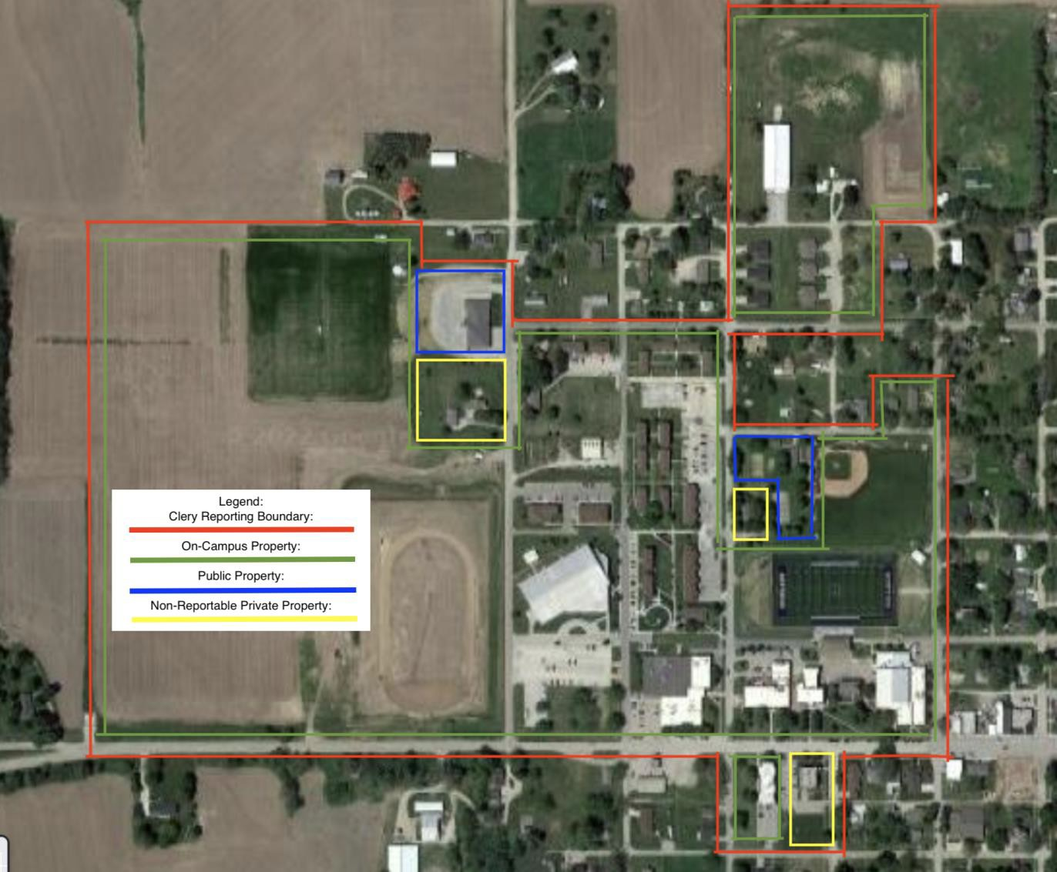

Softball Field, 207 East Pennsylvania, Highland, KS
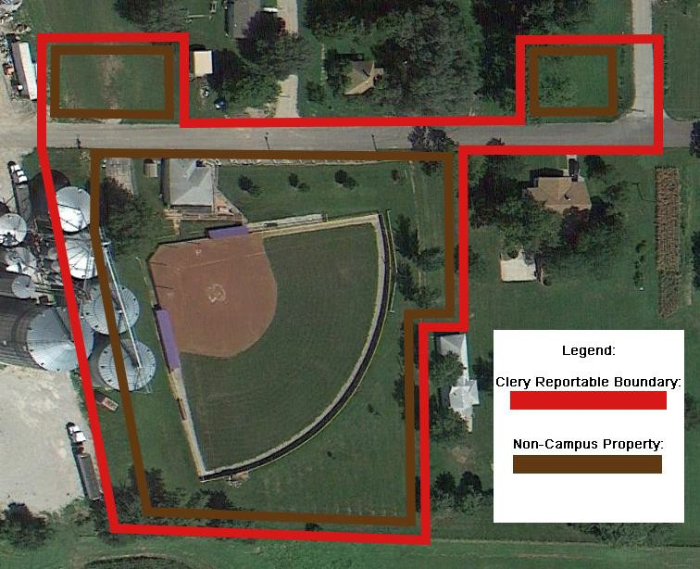

Ken Babcock Technical Center, 807 East Spring, Highland, KS 66035
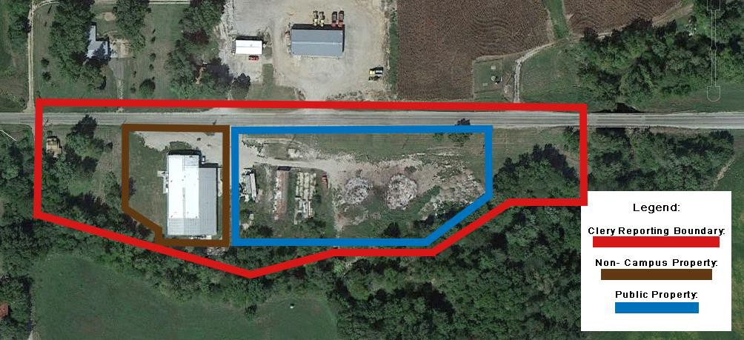

Klinefelter Farm, 1774 230th Street, Hiawatha, KS 66434
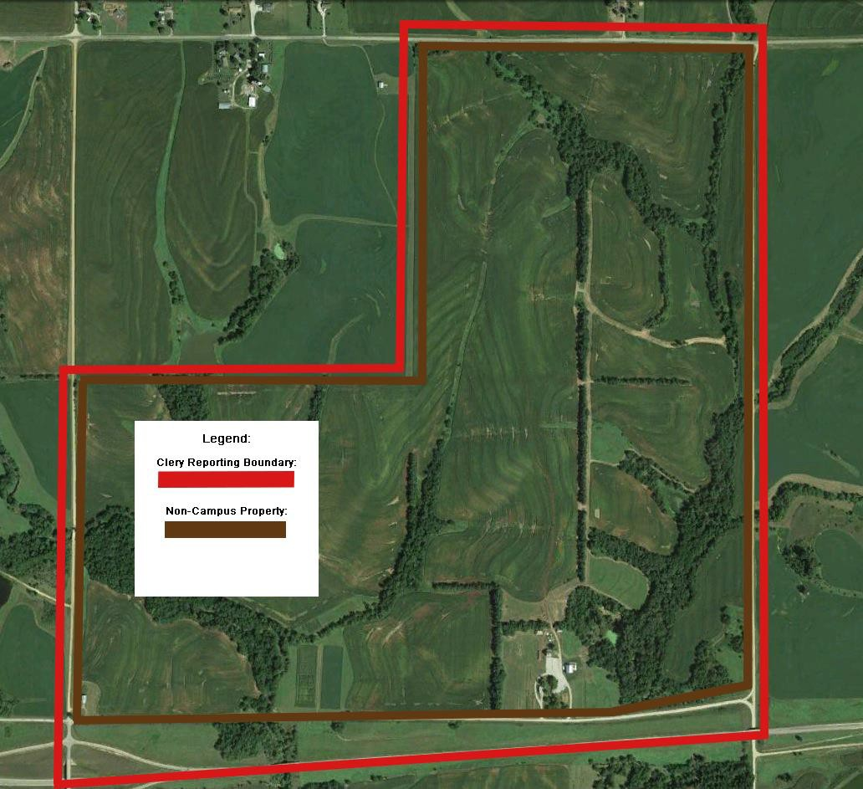

Highland Building Trades Site, 1202 N 6th St, Atchison, KS 66002
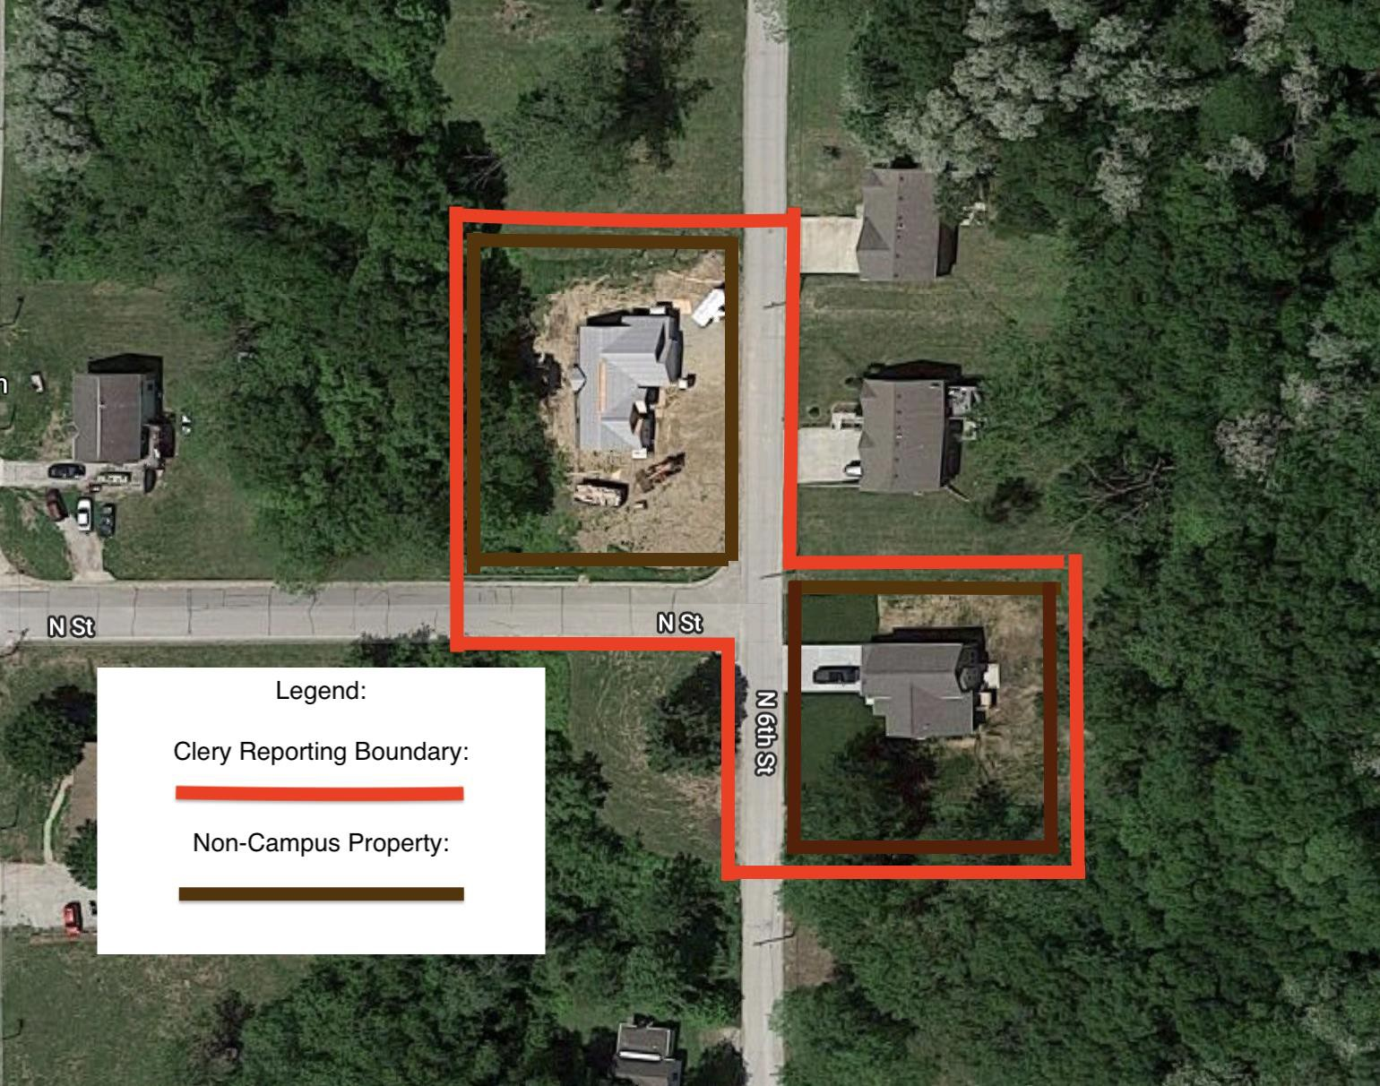

Atchison Center, 1501 West Riley, Atchison, KS 66002
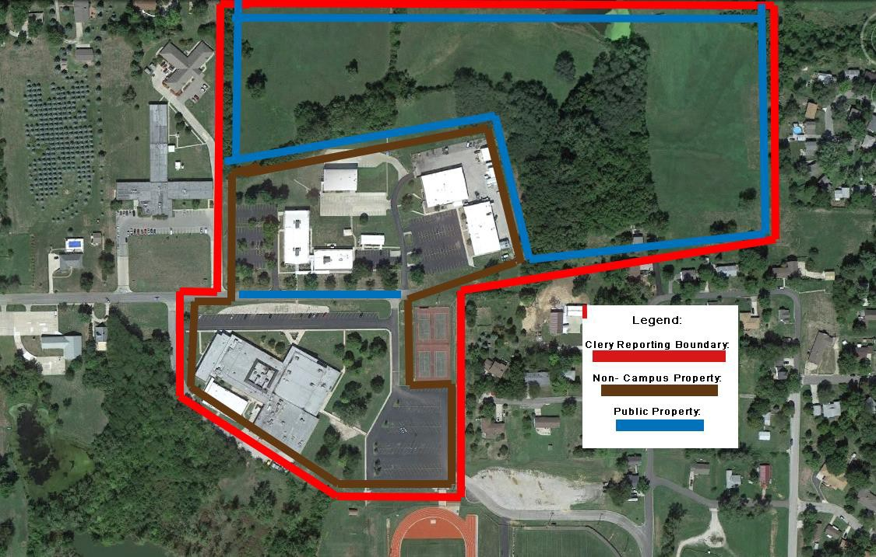

Electrical Technology Facility 17349 Country Club Rd Atchison, KS 66002
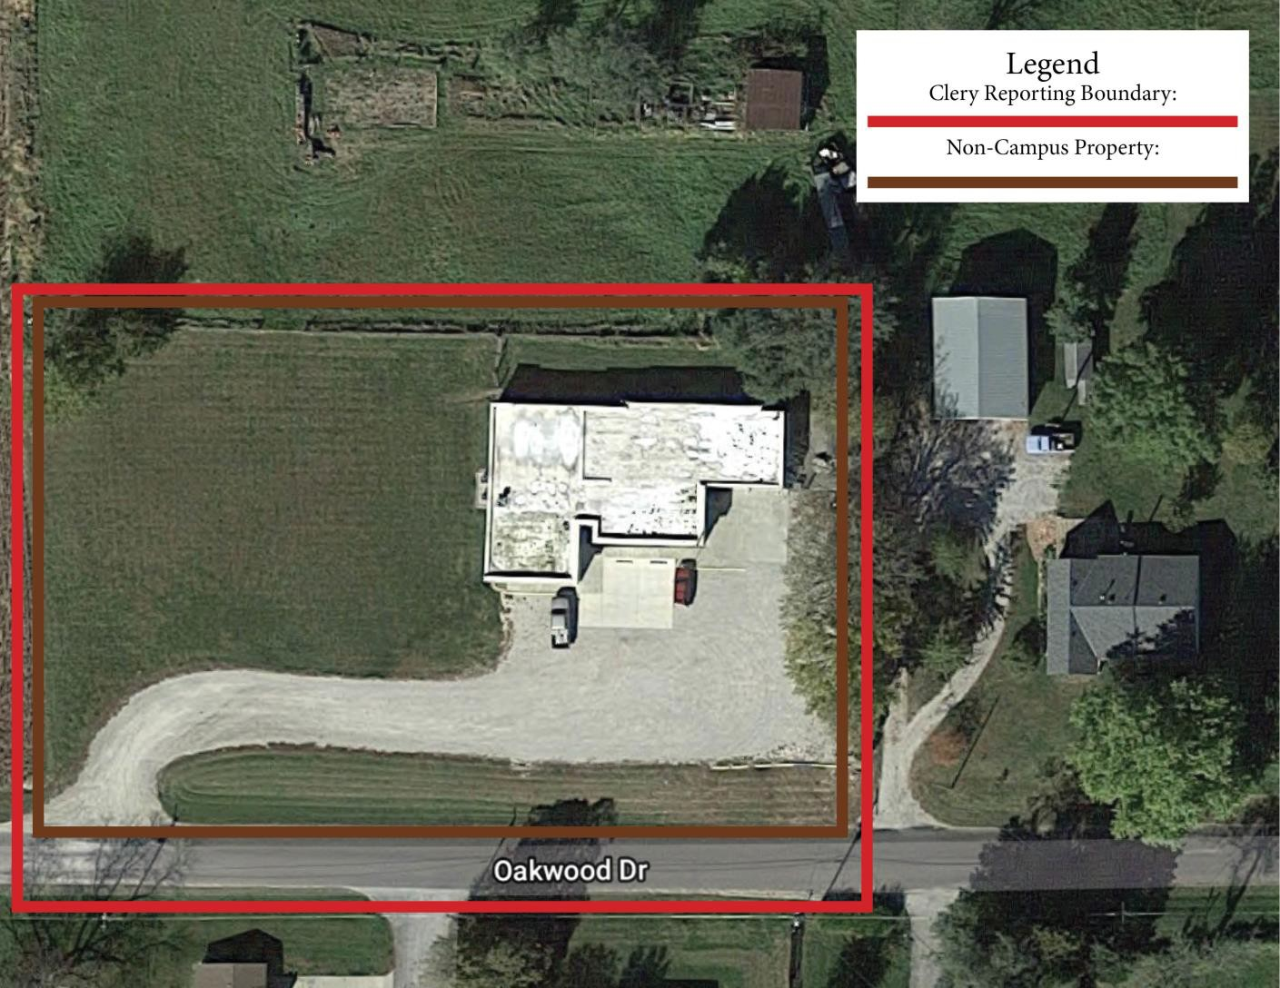

Construction Trades Building 2603 Industrial Rd Atchison, KS 66002
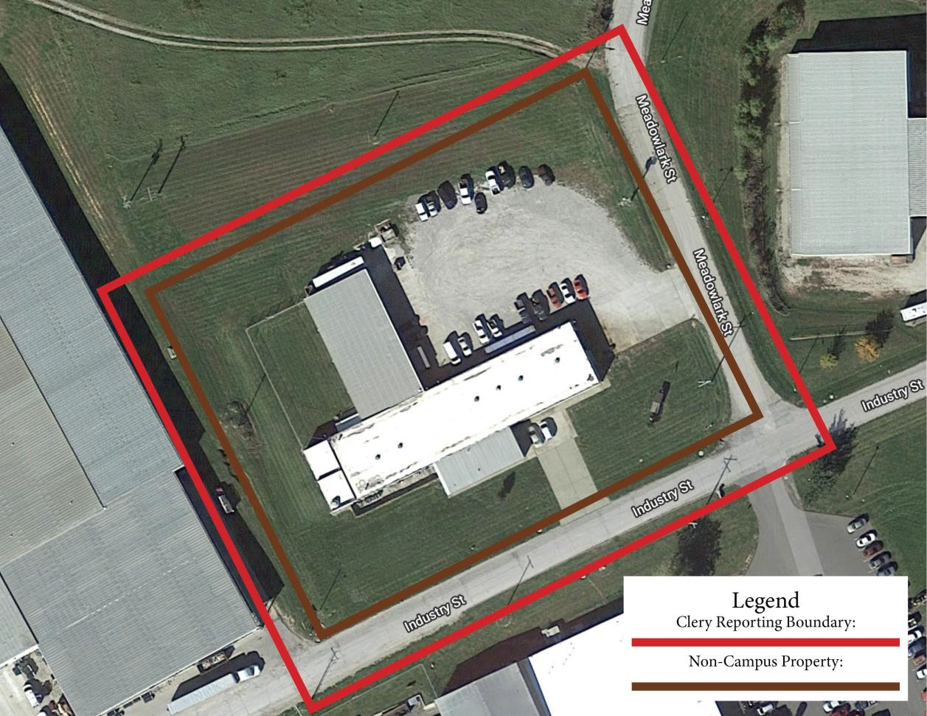

HCC Online Offices, 626 Nebraska Ave, Holton, KS 66436
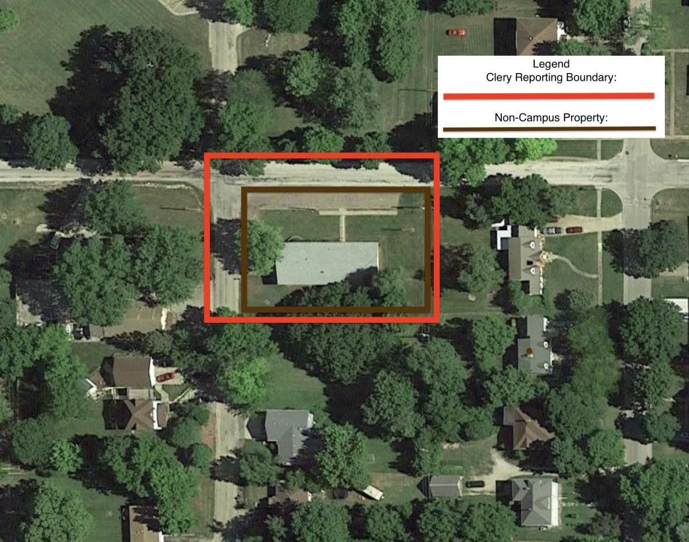

Wamego Center, 500 Miller Drive, Wamego, KS 66547
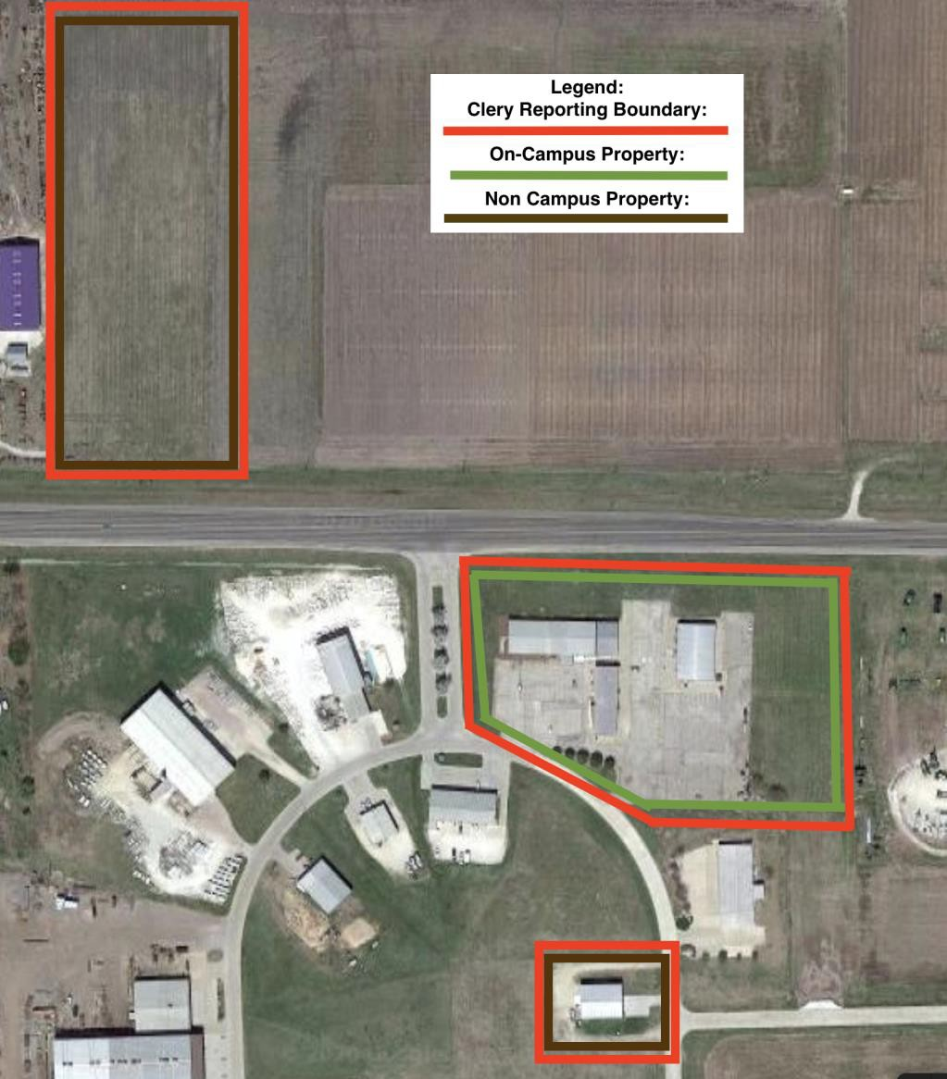

Western Center, 313 Nemaha, Baileyville, KS 66404
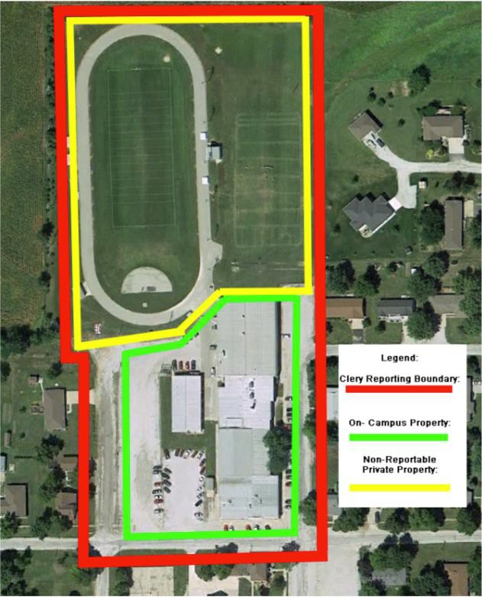

Western Center Acres, 317 168th Rd, Baileyville, KS 66404

Data from law enforcement agencies:
- The College was provided with some crime data from law enforcement agencies for which it cannot be determined whether any of the statistics apply to or include the College’s Clery Geography.
- Certain law enforcement agencies did not comply with the College’s request for crime statistics

Annual Fire Safety Report

Housing Facilities and Fire Safety Systems

The College maintains on-campus housing for its students. Below is a description of fire safety systems and the number of fire drills conducted during the previous calendar year. Campus: Highland Community College (Main Campus), 606 West Main Street, Highland, KS 66035-4165
Facility | Fire Alarm Monitoring Done on Site | Partial Sprinkler System | Full Sprinkler System | Smoke Detection | Fire Extinguisher Devices | Evacuation Plans & Placards | Number of evacuation (fire) drills in previous calendar year
Claymont, 304 N  Prairie |  |  |  | X | X |  | 4
Colony Point, 308 N Prairie |  |  |  | X | X |  | 4
Cornerstone, 306 N  Prairie |  |  |  | X | X |  | 4
Crestview, 302 N  Prairie |  |  |  | X | X |  | 4
Degginger, 312 N  Prairie |  |  |  | X | X |  | 4
Ellis Hall, 102 S  Elmira St | X |  |  | X | X |  | 4
Hampton, 406 N  Prairie |  |  |  | X | X |  | 4
Hearthford, 407 Elmira |  |  |  | X | X |  | 4
Heritage Hall, 205 N Elmira | X |  |  | X | X |  | 4
Highlander, 310 N  Prairie |  |  |  | X | X |  | 4
Hollyoak, 709 W  Missouri |  |  |  | X | X |  | 4

Huntington, 703 W  Missouri |  |  |  | X | X |  | 4
Kansas, 206 N Prairie | X |  |  | X | X |  | 4
Kiltie, 208 N Prairie | X |  |  | X | X |  | 4
Piper Hall, 808 W.  Ohio | X |  |  | X | X |  | 4
Prairie Hall, 804 W.  Ohio | X |  | X | X | X |  | 4
Rubeti Hall, 301 N.  Elmira | X |  |  | X | X |  | 4
Scottie Place, 801 N Missouri |  |  |  | X | X |  | 4
Sunflower Place, 803 W Missouri |  |  |  | X | X |  | 4

Policies on Portable Appliances, Smoking and Open Flames Open Flames
Due to fire safety concerns, all candles are prohibited in housing complexes. Open flames, burning incense and smoking are prohibited. Anyone in violation may be subject to fines and/or disciplinary action.

Overloading Outlets
Overloading outlets is dangerous. The circuit strains when it feeds the extra plugs that in turn cause conductors, plugs and receptacles to overheat. This may lead to melting wires and could start a fire.

Fuel and Fuel Powered Equipment
Fuel powered equipment is prohibited in housing complexes. This includes the storage of generators, mopeds, and motorcycles. Bottles of gas and flammable fuels are strictly prohibited. Anyone in violation may be subject to fines and/or disciplinary action.

Holiday Decorations
Christmas trees are strictly prohibited as they are a fire hazard. Anyone in violation may be subject to fines and/or disciplinary action.

Grills
Electric, gas, smokers or charcoal grills are not allowed in on-campus housing with the exception of the North Avenue Apartments, Brown House, and Blue House. Park grills have been placed around campus for students to use.

Fire Evacuation Procedures
A fire extinguisher can be found in the utility closet of each apartment. It is the residents’ responsibility to know where it is located and how to use it. In the case that the fire cannot be controlled by the fire extinguisher:
- Evacuate the building in an orderly fashion and immediately call 911.
- Notify Campus Security at 785-741-2206, immediately.
- Notify residents in the neighboring rooms with a “courtesy knock” to notify them
of a fire on your way out of your room.
- Residents and their guests are required to evacuate the building to their designated fire-safe zones (see below) when the fire alarms sound.
- Residents and guests will not be allowed to re-enter the building until the alarm has been silenced, and the ALL Clear has been given by the Highland Fire Department.
- Students who re-enter the apartment complex before the ALL Clear has been given will receive an insubordination fine.
HCC Student Housing Fire Safe Zone Areas
- Ellis Hall: Parking lot South of Ellis
- Piper/Prairie Hall: Parking lot North of Piper (Lot P)
- Kansas Hall: The sidewalk in front of the Walter’s Wellness Center
- Kiltie Hall: The sidewalk in front of the Walter’s Wellness Center
- Colony Point Hall: Gravel parking lot West of complex (Maintenance Shed Lot)
- Cornerstone Hall: Gravel parking lot West of complex (Maintenance Shed Lot)
- Claymont Hall: Gravel Parking lot East of complex (Lot G)
- Crestview Hall: Gravel Parking lot East of complex (Lot G)
- Hampton Hall: Gravel Parking lot South of complex (Lot G)
- Hollyoak Hall: Gravel Parking lot South of complex (Lot G)
- Hearthford Hall: Gravel Parking lot South of complex (Lot G)
- Huntington Hall: Gravel Parking lot South of complex (Lot G)
- Heritage Hall: Parking lot East of complex (Lot H)
- Rubeti Hall: Parking lot East of complex (Lot H)
- Highlander Hall: Gravel Parking lot West of complex (Maintenance Shed Lot)
- Degginger Hall: Gravel Parking lot East of complex (Lot G)
- Scottie Place Hall: Gravel Parking lot South of complex (Lot S)
- Sunflower Hall: Gravel Parking lot South of complex (Lot S)
- Brown House: Parking lot West of house (Community Center Parking Lot)
- Blue House: Parking lot Northwest of house (Community Center Parking Lot)

Fire Education and Training Programs
Members of the Student Life staff receive fire safety training prior to the start of every fall semester. Topics include a review of the fire safety plan, the fire safe zone areas, weather safety, and emergency evacuation procedures. The college will perform four unannounced fire drills in campus housing per academic year.

Reporting Fires
The College is required to disclose statistical data each year on all fires that occurred in on- campus student housing. When a fire alarm is pulled and/or the fire department responds to a fire, these incidents are captured. If you encounter a fire that presents an emergency situation, ensure your own safety and then please call 911.

There may also be instances when a fire is extinguished quickly, and an alarm is not pulled or a response by the fire department was not necessary. It is important that these incidents be recorded as well. Therefore, if you are aware of such a fire, see evidence of one or hear about one, you should contact HCC Housing at HCC Housing. When providing notification of a fire, give as much information as possible about the location, date, time, and cause of the fire.

Plans for Future Improvements
The College periodically reviews its fire safety protections and procedures. At this time, it has no plans for future improvements.

Fire Statistics Highland Community College (Highland Campus)

2024
No fires were reported in 2024.
2023
No fires were reported in 2023.

2022
No fires were reported in 2022.

